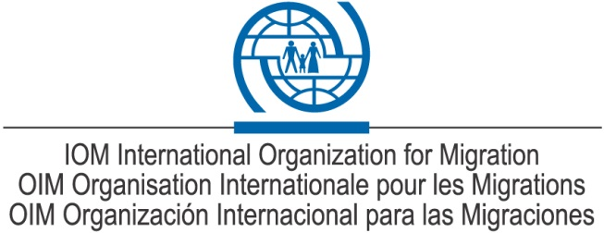

REQUEST FOR EXPRESSION OF INTEREST (EOI) TO SUPPLY VARIOUS SERVICES AND ITEMS
The International Organization for Migration (IOM) without obligation on its part herewith invites interested eligible and competent parties to submit their Expression of Interest (EOI) for possible Long term Agreement to supply various services and items for initial evaluation to IOM as listed below:

NO | ITEMS CATEGORY
1 | Vehicle rentals ( Taxis, 4x4, Buses, Trucks)
2 | Vehicles Repair and Maintenance Service Provision
3 | Office Building Cleaning Services
4 | Office Building Maintenances (Electricity Repair and Maintenance)
5 | Office Building Maintenances ( Air conditioning Repair & Maintenance)
6 | Office Building Maintenances (Plumbing Services)
7 | Office Building Maintenances (Generator repair & Maintenance)
8 | Customs Clearance services (Clearing Agent)
9 | Office Cleaning Supplies
10 | IT Repair and Maintenance
11 | Restaurant Services (onsite services)

All parties must submit the following documents:

- Company Profile including list of works in the past Five(5) years
- Last 5 high value service agreements/purchase orders
- Company Contact Person and details of physical address including telephone number and email address
- List of owners of the company with their shares (status)
- Copy of a valid Certificate of Official registration of the company (NIF & RC)
- List of References
- Bank statement for the last 2 years. (Account should be in the name of the company)
- Certificate to prove paid taxes (OBR & INSS)
- All Interested firms must submit their (EOI) together with the above documents via email to iomburundiprocurement2@iom.int, noting that attachments must not exceed 8MB otherwise the email will be rejected automatically by the server.
- Submissions deadline is on or before (30 November 2017 at 12:00 hrs.), any submission received after this date will not be considered.
- Only the pre-qualified vendors will receive a complete set of Bidding Documents via email address of parties provided in their profiles before 6th December 2017.
IOM reserves the right to accept or reject any submission and annul the prequalification process and reject all submissions at any time without thereby incurring any liability to the affected companies/Service providers.

AJ MORGEN

Chief of Mission
IOM Burundi

