FPU.SR- 19.5

REQUEST FOR PROPOSALS
(PROCUREMENT OF SERVICES)
For Simple Assignments

SERVICES FOR

Exchange Online Project

Prepared by



IOM MAC ICT Philippines

22th November 2017

REQUEST FOR PROPOSALS
RFP No.: RFP 9 - 28

Mission: Manila Administrative Centre

Project Name: Exchange Online Project

WBS: AD.0089.CH10.12.05.001.

Title of Services: MS Office 365 / Exchange Online Project

Request for Proposals

The International Organization for Migration (hereinafter called IOM) intends to hire Service Provider for the Exchange Online Project for which this Request for Proposals (RFP) is issued.

IOM now invites Service Providers/ Consulting Firms to provide Technical and Financial Proposal for the following Services: Exchange Online Project. More details on the services are provided in the attached Terms of Reference (TOR).

The Service Provider /Consulting Firm will be selected under a Quality –Cost Based Selection procedures described in this RFP.

The RFP includes the following documents:

Section I. Instructions to Service Providers/ Consulting Firms
Section II. Technical Proposal – Standard Forms
Section III. Financial Proposal – Standard Forms
Section IV. Terms of Reference
Section V. Standard Form of Contract
Section VI. VIS form
Section VII. Code of Conduct for Supplier

The Proposals must be delivered by hand or through mail to IOM with office address at 28th floor Citibank Tower Paseo De Roxas Makati City Philippines or to gpsu@iom.int and evargas@iom.int on or before 5pm of 10th of Janaury 2018 No late proposal shall be accepted.

IOM reserves the right to accept or reject any proposal and to annul the selection process and reject all Proposals at any time prior to contract award, without thereby incurring any liability to affected Service Providers/ Consulting Firms

Newton Muli
Head, ICT Infrastructure & Networks,
ITCSC - Network & Systems Unit

Table of Contents

Section I - Instructions to Service Providers/ Consulting Firms 5
Section II – Technical Proposal Standard Forms 14
Section III. Financial Proposal - Standard Forms 21
Section IV. Terms of Reference 26
Section V – Pro-forma Contract 27

Section I - Instructions to Service Providers/ Consulting Firms
1. Introduction

1.1 Only eligible Service Providers/ Consulting Firms may submit a Technical Proposal and Financial Proposal for the services required. The proposal shall be the basis for contract negotiations and ultimately for a signed contract with the selected Consultant Firm.

  - Service Providers/ Consulting Firms should familiarize themselves with local conditions and take them into account in preparing the proposal. Service Providers/ Consulting Firms are encouraged to visit IOM before submitting a proposal and to attend a pre-proposal conference if is specified in Item 2.3. of this Instruction.

1.3 The Service Providers/ Consulting Firms costs of preparing the proposal and of negotiating the contract, including visit/s to the IOM, are not reimbursable as a direct cost of the assignment.

1.4 Service Providers/ Consulting Firms shall not be hired for any assignment that would be in conflict with their prior or current obligations to other procuring entities, or that may place them in a position of not being able to carry out the assignment in the best interest of the IOM.

1.5 IOM is not bound to accept any proposal and reserves the right to annul the selection process at any time prior to contract award, without thereby incurring any liability to the Service Providers/ Consulting Firms.

  - IOM shall provide at no cost to the Service Provider/ Consulting Firm the necessary inputs and facilities, and assist the Firm in obtaining licenses and permits needed to carry out the services and make available relevant project data and report (see Section V. terms of reference).

2. Corrupt, Fraudulent, and Coercive Practices

2.1 IOM Policy requires that all IOM Staff, bidders, manufacturers, suppliers or distributors, observe the highest standard of ethics during the procurement and execution of all contracts. IOM shall reject any proposal put forward by bidders, or where applicable, terminate their contract, if it is determined that they have engaged in corrupt, fraudulent, collusive or coercive practices. In pursuance of this policy, IOM defines for purposes of this paragraph the terms set forth below as follows:

- Corrupt practice means the offering, giving, receiving or soliciting, directly or indirectly, of any thing of value to influence the action of the Procuring/Contracting Entity in the procurement process or in contract execution;

        - Fraudulent practice is any act or omission, including a misrepresentation, that knowingly or recklessly misleads, or attempts to mislead, the Procuring/Contracting Entity in the procurement process or the execution of a contract, to obtain a financial gain or other benefit to avoid an obligation;
        - Collusive practice is an undisclosed arrangement between two or more bidders designed to artificially alter the results of the tender procedure to obtain a financial gain or other benefit;

        - Coercive practice is impairing or harming, or threatening to impair or harm, directly or indirectly, any participant in the tender process to influence improperly its activities in a procurement process, or affect the execution of a contract

3. Conflict of Interest

3.1 All bidders found to have conflicting interests shall be disqualified to participate in the procurement at hand. A bidder may be considered to have conflicting interest under any of the circumstances set forth below:

- A Bidder has controlling shareholders in common with another Bidder;

- A Bidder receives or has received any direct or indirect subsidy from another Bidder;

- A Bidder has the same representative as that of another Bidder for purposes of this bid;

- A Bidder has a relationship, directly or through third parties, that puts them in a position to have access to information about or influence on the Bid of another or influence the decisions of the Mission/procuring Entity regarding this bidding process;

- A Bidder submits more than one bid in this bidding process;

- A Bidder who participated as a consultant in the preparation of the design or technical specifications of the Goods and related services that are subject of the bid.

4. Clarifications and Amendments to RFP Documents

4.1 At any time before the submission of the proposals, IOM may, for any reason, whether at its own initiative or in response to a clarification amend the RFP. Any amendment made will be made available to all short-listed Service Providers/ Consulting Firms who have acknowledged the Letter of Invitation.

4.2. Service Providers/ Consulting Firms may request for clarification(s) on any part of the RFP. The request must be sent in writing or by standard electronic means and submitted to IOM at the address indicated in the invitation at least (7) calendar days before the set deadline for the submission and receipt of Proposals. IOM will respond in writing or by standard electronic means to the said request and this will be made available to all those who acknowledged the Letter of Invitation without identifying the source of the inquiry.
4.3 For this purpose, a pre-proposal conference will be held on 15th of December 2017 3PM in ITC Conference room 28th flr. Citibank Tower Paseo De Roxas Makati City Philippines]. Attendance to the conference is optional.

5. Preparation of the Proposal

5.1 A Service Provider/ Consulting Firm Proposal shall have two (2) components:

a) the Technical Proposal, and
b) the Financial Proposal.

5.2 The Proposal, and all related correspondence exchanged by the Service Providers/ Consulting Firms and IOM, shall be in English. All reports prepared by the contracted Service Provider/ Consulting Firm shall be in English.

5.3 The Service Providers/ Consulting Firms are expected to examine in detail the documents constituting this Request for Proposal (RFP). Material deficiencies in providing the information requested may result in rejection of a proposal.

6. Technical Proposal

6.1 When preparing the Technical Proposal, Service Providers/ Consulting Firms must give particular attention
to the following:

- If a Service Provider/ Consulting Firm deems that it does not have all the expertise for the assignment, it may obtain a full range of expertise by associating with individual consultant(s) and/or other consultants or entities in a joint venture or sub-consultancy, as appropriate. Service Providers/ Consulting Firms may associate with the other consultants invited for this assignment or to enter into a joint venture with consultants not invited, only with the approval of IOM. In case of a joint venture, all partners shall be jointly and severally liable and shall indicate who will act as the leader of the joint venture.

b) For assignment of the staff, the proposal shall be based on the number of professional staff-months estimated by the firm, no alternative professional staff shall be proposed.

c) It is desirable that the majority of the key professional staff proposed is permanent employees of the firm or have an extended and stable working relationship with it.

- Proposed professional staff must, at a minimum, have the experience of at least Five years, preferably working under conditions similar to those prevailing in the country of the assignment.

  - The Technical Proposal shall provide the following information using the attached Technical Proposal Standard Forms TPF 1 to TPF 6 (Section III).

- A brief description of the Service Providers/ Consulting Firms organization and an outline of recent experience on assignments of a similar nature (TPF-2), if it is a joint venture, for each partner. For each assignment, the outline should indicate the profiles of the staff proposed, duration of the assignment, contract amount, and firm’s involvement.

- A description of the approach, methodology and work plan for performing the assignment (TPF-3). This should normally consist of maximum of ten (10) pages including charts, diagrams, and comments and suggestions, if any, on Terms of Reference and counterpart staff and facilities. The work plan should be consistent with the work schedule (TPF-7)

- The list of proposed Professional Staff team by area of expertise, the position and tasks that would be assigned to each staff team members (TPF-4).

- Latest CVs signed by the proposed professional staff and the authorized representative submitting the proposal (TPF-5) Key information should include number of years working for the firm and degree of responsibility held in various assignments during the last five years.

- A time schedule estimates of the total staff input (Professional and Support Staff, staff time needed to carry out the assignment, supported by a bar chart diagram showing the time proposed for each Professional and Staff team members (TPF–6). The schedule shall also indicate when experts are working in the project office and when they are working at locations away from the project office.

- A time schedule (bar chart) showing the time proposed to undertake that the activities indicated in the work plan (TPF-7).

- A detailed description of the proposed methodology and staffing for training if the RFP specifies training as specific component of the assignment.

6.3 The technical proposal shall not include any financial information.

7. Financial Proposal

7.1 In preparing the Financial Proposal, consultants are expected to take into account the requirements and conditions outlined in the RFP. The Financial Proposal shall follow the Financial Proposal Standard Forms FPF 1 to FPF 4 (Section IV).

7.2 The Financial proposal shall include all costs associated with the assignment. If appropriate, these costs should be broken down by activity. All items and activities described in the Technical proposal must be priced separately; activities and items in the Technical Proposal but not priced shall be assumed to be included in the prices of other activities or items.

7.3 The Service Provider/ Consulting Firm may be subject to local taxes on amounts payable under the Contract. If such is the case, IOM may either: a) reimburse the Service Provider/ Consulting Firm for any such taxes or b) pay such taxes on behalf of the Consultant. Taxes shall not be included in the sum provided in the Financial Proposal as this will not be evaluated, but they will be discussed at contract negotiations, and applicable amounts will be included in the Contract.

7.4. Service Providers/ Consulting Firms shall express the price of their services in USD.

7.5 The Financial Proposal shall be valid for 90 calendar days. During this period, the Service Provider/ Consulting Firm is expected to keep available the professional staff for the assignment. IOM will make its best effort to complete negotiations and determine the award within the validity period. If IOM wishes to extend the validity period of the proposals, the Service Provider/ Consulting Firm has the right not to extend the validity of the proposals.

8. Submission, Receipt, and Opening of Proposals

8.1 Service Providers/ Consulting Firms may only submit one proposal. If a Service Provider/ Consulting Firm submits or participates in more than one proposal such proposal shall be disqualified.

8.2 The original Proposal (both Technical and Financial Proposals) shall be prepared in indelible ink. It shall contain no overwriting, except as necessary to correct errors made by the Service Providers/ Consulting Firms themselves. Any such corrections or overwriting must be initialed by the person(s) who signed the Proposal.

  - The Service Providers/ Consulting Firms shall submit one original and one copy of the Proposal. Each Technical Proposal and Financial Proposal shall be marked “Original” or “Copy” as appropriate. If there are any discrepancies between the original and the copies of the Proposal, the original governs.

8.4 The original and all copies of the Technical Proposal shall be placed in a sealed envelope clearly marked “TECHNICAL PROPOSAL.” Similarly, the original Financial Proposal shall be placed in a sealed envelope clearly marked “FINANCIAL PROPOSAL” and with a warning “DO NOT OPEN WITH THE TECHNICAL PROPOSAL.” Both envelopes shall be placed into an outer envelope and sealed. The outer envelope shall be labeled with the submission address, reference number and title of the project and the name of the Service Provider/ Consulting Firm.

8.5 Proposals must be received by IOM at the place, date and time indicated in the invitation to submit proposal or any new place and date established by the IOM. Any Proposal submitted by the Service Provider/ Consulting Firm after the deadline for receipt of Proposals prescribed by IOM shall be declared “Late,” and shall not be accepted by the IOM and returned to the consultant unopened.

8.6 After the deadline for the submission of Proposals, all the Technical Proposal shall be opened first by the BEAC. The Financial Proposal shall remain sealed until all submitted Technical Proposals are opened and evaluated. The BEAC has the option to open the proposals publicly or not.

9. Evaluation of Proposals

9.1 After the Proposals have been submitted to the BEAC and during the evaluation period, Service Providers/ Consulting Firms that have submitted their Proposals are prohibited from making any kind of communication with any BEAC member, as well as its Secretariat regarding matters connected to their Proposals. Any effort by the Service Providers/ Consulting Firms to influence IOM in the examination, evaluation, ranking of Proposal, and recommendation for the award of contract may result in the rejection of the Service Providers/ Consulting Firms Proposal.

10. Technical Evaluation

10.1 The entire evaluation process, including the submission of the results and approval by the approving authority, shall be completed in not more than twenty-one (21) calendar day] after the deadline for receipt of proposals.

10.2 The BEAC shall evaluate the Proposals on the basis of their responsiveness to the Terms of Reference, compliance to the requirements of the RFP and by applying an evaluation criteria, sub criteria and point system. Each responsive proposal shall be given a technical score (St). The proposal with the highest score or rank shall be identified as the Highest Rated/Ranked Proposal.

10.3 A proposal shall be rejected at this stage if it does not respond to important aspects of the TOR or if it fails to achieve the minimum technical qualifying score which is 70%.

10.4 The technical proposals of Service Providers/ Consulting Firms shall be evaluated based on the following criteria and sub-criteria:
Points

(i) Specific experience of the Service Providers/ Consulting Firms relevant to
the assignment: [10]
[Normally, sub-criteria are not provided]

(ii) Adequacy of the proposed methodology and work plan in response to the
Terms of Reference:

a) Technical approach and methodology [45]
b) Work plan [20]
c) Organization and staffing [10]
Total points for criterion (ii): [75]

(iii) Key professional staff qualifications and competence for the assignment:

b) A detailed description of the firm’s project
management team including skills, experience
and capabilities of relevant staff. [15]

Total points for criterion (iii): [15]

The number of points to be assigned to each of the above positions or
disciplines shall be determined considering the following three sub-criteria and relevant percentage weights:

1) General qualifications [Insert weight between 20 and 30%]
2) Adequacy for the assignment [Insert weight between 50 and 60%]
3) Experience in region and language [Insert weight between 10 and 20%]
Total weight: 100%

The minimum technical score St required to pass is: 85% Points

10.5 Technical Proposal shall not be considered for evaluation in any of the following cases:

a) late submission, i.e., after the deadline set
b) failure to submit any of the technical requirements and provisions provided under the Instruction to Service Provider/ Consulting Firm (ITC) and Terms of Reference (TOR);

11. Financial Evaluation

11.1 After completion of the Technical Proposal evaluation, IOM shall notify those Service Providers/ Consulting Firms whose proposal did not meet the minimum qualifying score or were considered non responsive based on the requirements in the RFP, indicating that their Financial Proposals shall be returned unopened after the completion of the selection process.

11.2 IOM shall simultaneously notify the Service Providers/ Consulting Firms that have passed the minimum qualifying score indicating the date and opening of the Financial Proposal. The BEAC has the option to open the Financial proposals publicly or not.

11.3 The BEAC shall determine the completeness of the Financial Proposal whether all the Forms are present and the required to be priced are so priced.

  - The BEAC will correct any computational errors. In case of a discrepancy between a partial amount and the total amount, or between words and figures, the former will prevail. In addition, activities and items described in the Technical proposal but not priced, shall be assumed to be included in the prices of other activities or items.

  - The Financial Proposal of Service Providers/ Consulting Firms who passed the qualifying score shall be opened, the lowest Financial Proposal (F1) shall be given a financial score (Sf) of 100 points. The financial scores (Sf) of the other Financial Proposals shall be computed based on the formula :

Sf = 100 x Fl / F

Where:

Sf - is the financial score of the Financial Proposal under consideration,
Fl - is the price of the lowest Financial Proposal, and
F - is the price of the Financial Proposal under consideration.

The proposals shall then be ranked according to their combined (Sc) technical (St) and financial (Sf) scores using the weights (T = the weight given to the Technical Proposal = 0.80; F = the weight given to the Financial Proposal = 0.20; T + F = 1)

Sc = St x T% + Sf x F%

The firm achieving the highest combined technical and financial score will be invited for negotiations.

12. Negotiations

12.1 The aim of the negotiation is to reach agreement on all points and sign a contract. The expected date and address for contract negotiation is 20th of January 2018

12.2 Negotiation will include: a) discussion and clarification of the Terms of Reference (TOR) and Scope of Services; b) Discussion and finalization of the methodology and work program proposed by the Service Provider/ Consulting Firm; c) Consideration of appropriateness of qualifications and pertinent compensation, number of man-months and the personnel to be assigned to the job, and schedule of activities (manning schedule); d) Discussion on the services, facilities and data, if any, to be provided by IOM; e) Discussion on the financial proposal submitted by the Service Provider/ Consulting Firm; and f) Provisions of the contract. IOM shall prepare minutes of negotiation which will be signed both by IOM and the Service Providers/ Consulting Firms.

12.3 The financial negotiations will include clarification on the tax liability and the manner in which it will be reflected in the contract and will reflect the agreed technical modifications (if any) in the cost of the services. Unless there are exceptional reasons, the financial negotiations will involve neither the remuneration rates for staff nor other proposed unit rates.

12.4 Having selected the Service Provider/ Consulting Firm on the basis of, among other things, an evaluation of proposed key professional staff, IOM expects to negotiate a contract on the basis of the experts named in the proposal. Before contract negotiations, IOM shall require assurances that the experts shall be actually available. IOM will not consider substitutions during contract negotiation unless both parties agree that the undue delay in the selection process makes such substitution unavoidable or for reasons such as death or medical incapacity. If this is not the case and if it is established that staff were referred in their proposal without confirming their availability the Service Provider/ Consulting Firm may be disqualified. Any proposed substitution shall have equivalent or better qualifications and experience than the original candidate.

12.5 All agreement in the negotiation will then be incorporated in the description of services and form part of the Contract.

12.6 The negotiations shall conclude with a review of the draft form of the Contract which forms part of this RFP (Section VI). To complete negotiations, IOM and the Service Providers/ Consulting Firms shall initial the agreed Contract. If negotiations fail, IOM shall invite the second ranked Service Provider/ Consulting Firm to negotiate a contract. If negotiations still fail, the IOM shall repeat the process for the next-in-rank Service Providers/ Consulting Firms until the negotiation is successfully completed.

13. Award of Contract

13.1 The contract shall be awarded, through a notice of award, following negotiations and subsequent post-qualification to the Service Provider/ Consulting Firm with the Highest Rated Responsive Proposal. Thereafter, the IOM shall promptly notify other Service Providers/ Consulting Firms on the shortlist that they were unsuccessful and shall return their unopened Financial Proposals. Notification will also be sent to those Service Providers/ Consulting Firms who did not pass the technical evaluation.
  - The Service Provider/ Consulting Firm is expected to commence the assignment on 30th of January 2018

14. Confidentiality

    - Information relating to the evaluation of proposals and recommendations concerning awards shall not be disclosed to the Service Provider/ Consulting Firm who submitted Proposals or to other persons not officially concerned with the process. The undue use by any Service Provider/ Consulting Firm of confidential information related to the process may result in the rejection of its Proposal and may be subject to the provisions of IOM’s anti-fraud and corruption policy.

Section II – Technical Proposal Standard Forms

TPF-1: Technical Proposal Submission Form

[Location, Date]

To: [Chairperson Name and address of IOM Mission]

Ladies/Gentlemen:

We, the undersigned, offer to provide the Services for [insert Title of consulting services] in accordance with your Request for Proposal (RFP) dated [insert Date] and our Proposal. We are hereby submitting our Proposal, which includes this Technical Proposal, and a Financial Proposal sealed under a separate envelope.

If negotiations are held after the period of validity of the Proposal, we undertake to negotiate on the basis of the proposed staff. Our Proposal is binding upon us and subject to the modifications resulting from Contract negotiations.

We acknowledge and accept IOM’s right to inspect and audit all records relating to our Proposal irrespective of whether we enter into a contract with IOM as a result of this proposal or not.

We understand you are not bound to accept any Proposal you receive.

We remain,

Yours sincerely,

Authorized Signature:
Name and Title of Signatory:
Name of Firm:
Address:
TPF – 2: Service Providers/ Consulting Firms Organization

[Provide here brief (two pages) description of the background and organization of your firm/entity and each associate for the assignment (if applicable).]

TPF – 3: Description of the Approach, Methodology and Work Plan for Performing the Assignment

[The description of the approach, methodology and work plan should normally consist of 10 pages, including charts, diagrams, and comments and suggestions, if any, on Terms of reference and counterpart staff and facilities.]

TPF – 4: Team Composition and Task Assignments

1. Technical/Managerial Staff
Name | Position | Task

2. Support Staff
Name | Position | Task

TPF – 5: Format of Curriculum Vitae (CV) for Proposed Professional Staff

Proposed Position:
Name of Firm:
Name of Staff:
Profession:
Date of Birth:
Years with Firm/Entity: Nationality:
Membership in Professional Societies:

Detailed Tasks Assigned:

Key Qualifications:
[Give an outline of staff member’s experience and training most pertinent to tasks on assignment. Describe degree of responsibility held by staff member on relevant previous assignments and give dates and locations. Use about half a page.]

Education:
[Summarize college/university and other specialized education of staff member, giving names of schools, dates attended, and degrees obtained. Use about one quarter of a page.]

Employment Record:
[Starting with present position, list in reverse order every employment held. List all positions held by staff member since graduation, giving dates, names of employing organizations, titles of positions held, and locations of assignments. For experience in last ten years, also give types of activities performed and client references, where appropriate. Use about two pages.]

Languages:
[For each language indicate proficiency: excellent, good, fair, or poor in speaking, reading, and writing.]

Certification:

I, the undersigned, certify that to the best of my knowledge and belief, these data correctly describe me, my qualifications, and my experience. I understand that any willful misstatement described herein may lead to my disqualification or dismissal, if engaged.

Date:
[Signature of staff member and authorized representative of the firm] Day/Month/Year

Full name of staff member:______________________________________
Full name of authorized representative: __________________________
TPF-6: Time Schedule for Professional Personnel
 |  |  | Months (in the Form of a Bar Chart)
Name | Position | Reports Due/Activities | 1 | 2 | 3 | 4 | 5 | 6 | 7 | 8 | 9 | 10 | 11 | 12 | Number of Months
 |  |  |  |  |  |  |  |  |  |  |  |  |  |  | Subtotal (1) ________________
 |  |  |  |  |  |  |  |  |  |  |  |  |  |  | Subtotal (2) ________________
 |  |  |  |  |  |  |  |  |  |  |  |  |  |  | Subtotal (3) ________________
 |  |  |  |  |  |  |  |  |  |  |  |  |  |  | Subtotal (4) ________________
Full-time: Part-time:
Reports Due:
Activities Duration:
Location
Signature of Authorized Representative: ______________________
Full Name: _____________________________
Title : ________________________________
TPF-7: Activity (Work) Schedule
A. Field Investigation and Other Activities
No. | Activity/Work Description | Duration
No. | Activity/Work Description | 1st | 2nd | 3rd | 4th | 5th | 6th | 7th | 8th | 9th | 10th | 11th | 12th
1
2
3
4
5

B. Completion and Submission of Reports
Reports | Date
1. Inception Report
2. Interim Progress Report
(a) First Status Report
(b) Second Status Report
3. Draft Report
4. Final Report

Section III. Financial Proposal - Standard Forms

FPF-1: Financial Proposal Submission Form

[Location, Date]

To: [Name of Chairperson and address of IOM Mission]

Ladies/Gentlemen:

We, the undersigned, offer to provide the consulting services for [insert Title of consulting services] in accordance with your Request for Proposal (RFP) dated [insert date] and our Proposal (Technical and Financial Proposals). Our attached Financial Proposal is for the sum of [Amount in words and figures]. This amount is exclusive of the local taxes, which we have estimated at [Amount(s) in words and figures].

Our Financial Proposal shall be binding upon us subject to the modifications resulting from Contract negotiations, up to expiration of the validity period of [insert validity period] of the Proposal.

We acknowledge and accept the IOM right to inspect and audit all records relating to our Proposal irrespective of whether we enter into a contract with the IOM as a result of this Proposal or not.

We confirm that we have read, understood and accept the contents of the Instructions to Service Providers/ Consulting Firms (ITC), Terms of Reference (TOR), the Draft Contract, the provisions relating to the eligibility of Service Providers/ Consulting Firms, any and all bulletins issued and other attachments and inclusions included in the RFP sent to us.

We understand you are not bound to accept any Proposal you receive.

We remain,

Yours sincerely,
Authorized Signature:
Name and Title of Signatory:
Name of Firm:
Address:

FPF– 2: Summary of Costs

Costs | Currency | Amount(s)
I – Remuneration Cost (see FPF- 3 for breakdown)
II - Reimbursable Cost ( see FPF – 4 for breakdown)

Total Amount of Financial Proposal ¹

¹ Indicate total costs, net of local taxes, to be paid by IOM in each currency. Such total costs must coincide with the sum of the relevant
subtotal indicated in all Forms FPF-3 provided with the Proposal.

Authorized Signature:
Name and Title of Signatory:

FPF-3: Breakdown of Costs by Activity
Group of Activities (Phase):²  _____________________________________  _____________________________________ | Description: ³  _____________________________________________________________  _____________________________________________________________
Cost Component | Costs
Cost Component | Currency | Amount
Remuneration ⁴
Reimbursable Expenses ⁴
Subtotals

¹ Form FPF3 shall be filed at least for the whole assignment. In case some of the activities require different modes of billing and payment
(e.g. the assignment is phased, and each phase has a different payment schedule), the Service Provider/ Consulting Firm shall fill a
separate Form FPF-3 for each Group of activities.
² Names of activities (phase) should be same as, or corresponds to the ones indicated in Form TPF-8.
³ Short description of the activities whose cost breakdown is provided in this Form.
⁴ For each currency, Remuneration and Reimbursable Expenses must coincide with relevant Total Costs indicated in FPF-4 and FPF-5.

Authorized Signature:
Name and Title of Signatory:

FPF-4: Breakdown of Remuneration per Activity
[Information provided in this Form should only be used to establish payments to the Service Provider/ Consulting Firm for possible additional services requested by Client/IOM]

Name of Staff | Position | Staff-month Rate
Professional Staff
1.
2.
3.
4.
5.
Support Staff
1.
2.
3.
4.
5.

¹ Names of activities (phase) should be same as, or corresponds to the ones indicated in
Form TPF-8.
² Short description of the activities whose cost breakdown is provided in this Form.

Authorized Signature:
Name and Title of Signatory:

FPF-5: Breakdown of Reimbursable Expenses
[Information provided in this Form should only be used to establish payments to the Service Provider/ Consulting Firm for possible additional services requested by Client/IOM]

Description¹ | Unit | Unit Cost²
1. Subsistence Allowance
2. Transportation Cost
3. Communication Costs
4. Printing of Documents, Reports, etc
5. Equipment, instruments, materials,
supplies, etc
6. Office rent, clerical assistance

¹ Delete items that are not applicable or add other items according to Paragraph 7.2 of Section
II-Instruction to Service Providers/ Consulting Firms
² Indicate unit cost and currency.

Authorized Signature:
Name and Title of Signatory:

Section IV. Terms of Reference
- Executive Summary

The International Organization for Migration is seeking proposals from qualified vendors to provide MSOffice 365 system and implementation services. The scope of the project will be migrating exchange 2003/2010 environment to an Office 365 hybrid hosted email services.

- Organization information

Established in 1951, IOM is an international intergovernmental organization part of the United Nations system, headquartered in Geneva and is the world’s leading organization on migration, with 165 member states and offices in more than 150 countries. The breadth and depth of IOM’s work reflect a level of experience and expertise in providing migrant services that is unmatched in the international community. IOM is committed to the principle that humane and orderly migration benefits migrants and society. IOM works with its partners in the international community to assist in meeting the growing operational challenges of migration, advance understanding of migration issues, encourage social and economic development through migration and uphold the well-being and human rights of migrants.

IOM provides its services through a world-wide network of more than 400 field locations in more than 150 countries, including 9 Regional Offices, and 2 Administrative Centers located in Panama and Manila, which provide core support in the areas of information technology, finance, human resources and other administrative services to IOM’s network of offices

- Background

IOM Exchange environment is spread around the globe with two main hubs (Manila and Geneva) hosting almost 50% of the total mailboxes. Some of the offices have their own exchange servers while others are hosted on the hubs.

The Requirements are tosetup, implement, deploy, configure and migration services of users from existing Exchange organization to the new Exchange organization and to the Exchange Online cloud services. Respondents should provide specific details of the design, implementation and project timeline. The mailboxes that need to be migrated to the cloud and to the new on-premise exchange is in Geneva and Manila hub sites.

Below is the design concept of the project.
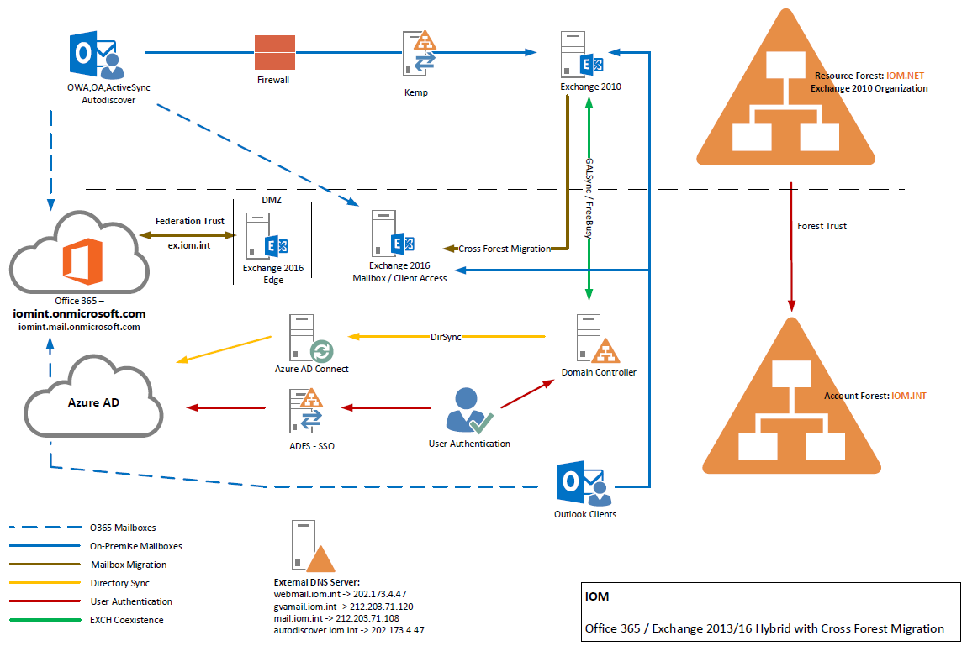

Connection overview between hub sites and Mission offices.

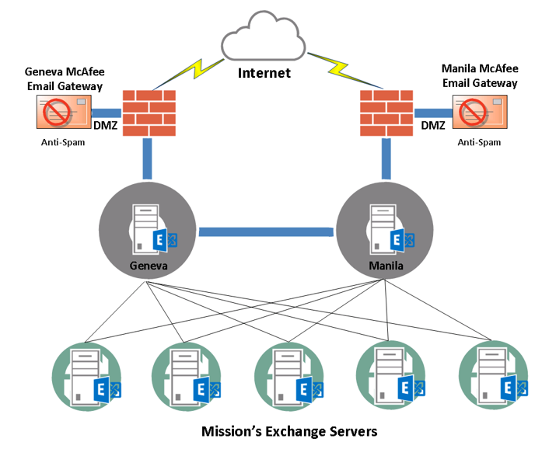

Disaster Recovery site is also implemented in the current infrastructure that is hosted in Panama DR Site. Replicated DAG traffic from Manila and Geneva Exchange servers.

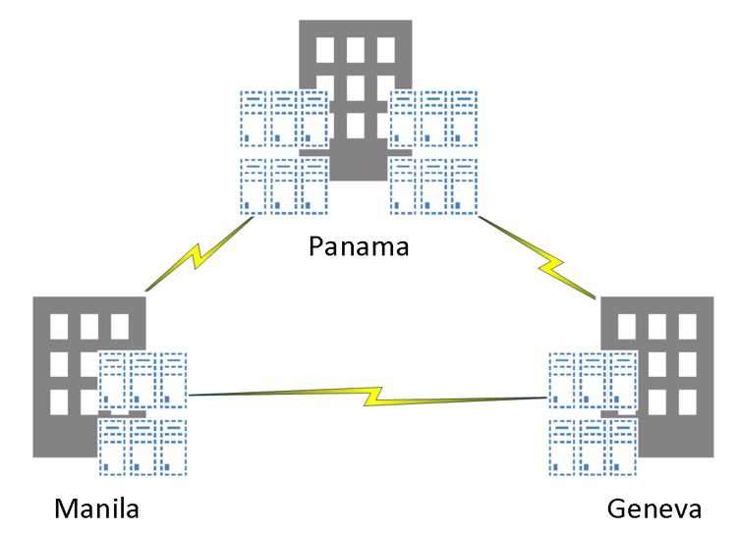

Exchange version:
- Exchange 2010 SP3 rollup 16 (Manila, Panama DR, Geneva Hub sites) – 29 servers
- Exchange 2010 SP2 rollup 6 (Mission offices) - 46 servers
- Exchange 2003 SP2
Exchange object count: (as of September 2017)
- Exchange 2010 Mailboxes – 20,295 (including idle, department and service accounts)
- Exchange 2003 mailboxes – 190 accounts (135 idle and system accounts)
- Exchange Groups – 5,279 groups
- Exchange Mail Contact – 2431 contacts

Initial design concept can be updated or revised if needed to follow the recommended implementation.

- Project description
The project aims at implementing Exchange hybrid setup with the new forest and Exchange Online.
The following objectives should be met:
- A detailed technical document and solution plan, which will provide a thorough and clearly-defined plan for a seamless migration to Exchange Online including a focus on the hybrid implementation, communication and admin training requirements.
- Onsite review of IOM systems to gather and capture information about existing infrastructure
- Identify potential challenges in this migration and propose solutions
- Recommend a solid communications and training plan for IOM admin users based on best practices.
- Determine required tasks for configuring network and DNS
- Check and verify existing User Identity and Account Provisioning.
- Planning considerations to implement directory synchronization.
- Check the existing Active Directory Federation Services for use with single sign-on.
- Exchange Online Planning
- Configuration of Exchange Online protection
- Develop migration strategy.
- Identify mailbox size and item counts that will be migrated to Exchange Online
- Determine mail-enabled applications and plan for configuration
- Calculate migration velocity for mailbox data.

- Scope
The service should include the following:
- Installation and configuration of Exchange 2016 on the new forest (iom.int).
- Configure coexistence between Exchange organization.
- Perform synchronization between exchange organization.
- Perform user mailbox migration between exchange organization.
- Configure the required DNS hostnames.
- Install and configure address rewrite for the new exchange organization.
- Configure Exchange hybrid setup between Exchange online.
- Perform mailbox migration for all mailboxes hosted in Manila, Panama and Geneva to Exchange Online.
- Configure Office 365 / Exchange online additional features.
- Configuration of Exchange Online Protection.
- Account provisioning
IOM will provide required MS windows servers and license for the implementation.
IOM will allocate dedicated Email specialists and staff to assist with required analysis and work alongside the partner/vendor team to increase resources for the migration and implementation.
- Timeline/Timescale
Vendor should provide timeline based on their proposed design and implementation plan.

Section V – Pro-forma Contract

FPU.SF.19.20

**This is a template Agreement only and will need to be modified according to the needs of the particular situation. All Agreements must be checked by Legal Services prior to signature **

Service Agreement
Between
The International Organization for Migration
And
[Name of the Other Party]
On
[Type of Services]

1. Introduction and Integral Documents

The Service Provider agrees to provide IOM with [insert brief description of services] in accordance with the terms and conditions of this Agreement and its Annexes, if any.
The following documents form an integral part of this Agreement: [add or delete as required]
Bid/Quotation Form
Price Schedule
Delivery Schedule and Terms of Reference
Accepted Notice of Award (NOA)

2. Parties

The Parties to this Agreement are the International Organization for Migration, Mission in [XXX], [Address of the Mission], represented by [Name, Title of Chief of Mission etc.], hereinafter referred to as IOM, and [Name of the Other Party], [Address], represented by [Name, Title of the representative of the Other Party], hereinafter referred to as the Service Provider.

3. Services Supplied

3.1 The Service Provider agrees to provide to the IOM the following services (the “Services”):
[Outline services to be provided. Where relevant, include location and how frequently etc. services are to be provided. List all the deliverables and their date of submission, if applicable. It may be necessary to attach a description of the Services as an Annex.]
3.2 The Service Provider shall commence the provision of Services from [date] and fully and satisfactorily complete them by [date].
3.3 The Service Provider agrees to provide the Services required under this Agreement in strict accordance with the specifications of this Article and any attached Annexes...

4. Charges and Payments

4.1 The all inclusive Service fee for the Services under this Agreement shall be USD XXX, which is the total charge to the IOM.
4.2 The Service Provider shall invoice IOM upon completion of all the services The invoice shall include: [services provided, hourly rate, number of hours billed, any travel and out of pocket expenses, (add/delete as necessary)]
4.3 Payments shall become due [insert number of days] days after IOM’s receipt and approval of the invoice. Payment shall be made in [Currency] by [bank transfer] to the following bank account: [insert the Service Provider’s bank account details].
4.4 The Service Provider shall be responsible for the payment of all taxes, duties, levies and charges assessed on the Service Provider in connection with this Agreement.
4.5 IOM shall be entitled, without derogating from any other right it may have, to defer payment of part or all of the Service fee until the Service Provider has completed to the satisfaction of IOM the services to which those payments relate.

5. Warranties

The Service Provider warrants that:
- It is a company financially sound and duly licensed, with adequate human resources, equipment, competence, expertise and skills necessary to provide fully and satisfactorily, within the stipulated completion period, all Services in accordance with this Agreement;
- It shall comply with all applicable laws, ordinances, rules and regulation when performing its obligations under this Agreement
- In all circumstances it shall act in the best interests of IOM;
- No official of IOM or any third party has received or will be offered by the Service Provider any direct or indirect benefit arising from the Agreement or award thereof;
- It has not misrepresented or concealed any material facts in the procuring of this Agreement;
- The Service Provider, its staff or shareholders have not previously been declared by IOM ineligible to be awarded agreements by IOM;
- It has or shall take out relevant insurance coverage for the period the Services are provided under this Agreement;
- It will abide by the highest ethical standards in the performance of this Agreement, which includes not engaging in any discriminatory or exploitative practice or practice inconsistent with the rights set forth in the Convention on the Rights of the Child;
- The Price specified in clause 4.1 of this Agreement shall constitute the sole remuneration in connection with this Agreement. The Service Provider shall not accept for its own benefit any trade commission, discount or similar payment in connection with activities pursuant to this Agreement or the discharge of its obligations thereunder. The Service Provider shall ensure that any subcontractors, as well as the personnel and agents of either of them, similarly, shall not receive any such additional remuneration.

6. Audit

The Service Provider agrees to maintain financial records, supporting documents, statistical records and all other records relevant to the Services in accordance with generally accepted accounting principles to sufficiently substantiate all direct and indirect costs of whatever nature involving transactions related to the provision of Services under this Agreement. The Service Provider shall make all such records available to IOM or IOM's designated representative at all reasonable times until the expiration of seven years from the date of final payment, for inspection, audit, or reproduction. On request, employees of the Service Provider shall be available for interview.

7. Independent Contractor

The Service Provider shall perform all Services under this Agreement as an independent contractor and not as an employee, partner, or agent of IOM.

8. Dispute resolution

Any dispute, controversy or claim arising out of or in relation to this Agreement, or the breach, termination or invalidity thereof, shall be settled amicably by negotiation between the Parties. In the event that such negotiation is unsuccessful, either Party may submit the dispute to arbitration. The arbitration will be carried out in accordance with the UNCITRAL arbitration rules. The arbitral award will be final and binding.

9. Delays/Non-Performance

9.1 If, for any reason, the Service Provider does not carry out or is not able to carry out its obligations under this Agreement and/or according to the project document, it must give notice and full particulars in writing to IOM as soon as possible. In the case of delay or non-performance, IOM reserves the right to take such action as in its sole discretion is considered to be appropriate or necessary in the circumstances, including imposing penalties for delay or terminating this Agreement.

9.2 Neither party will be liable for any delay in performing or failure to perform any of its obligations under this Agreement if such delay or failure is caused by force majeure, such as civil disorder, military action, natural disaster and other circumstances which are beyond the control of the party in question. In such event, the party will give immediate notice in writing to the other party of the existence of such cause or event and of the likelihood of delay.

10. Confidentiality

All information which comes into the Service Provider’s possession or knowledge in connection with this Agreement is to be treated as strictly confidential. The Service Provider shall not communicate such information to any third party without the prior written approval of IOM. The Service Provider shall comply with IOM Data Protection Principles in the event that it collects, receives, uses, transfers or stores any personal data in the performance of this Agreement. These obligations shall survive the expiration or termination of this Agreement.

11. Notices

Any notice given pursuant to this Agreement will be sufficiently given if it is in writing and delivered, or sent by prepaid post or facsimile to the other Party at the following address:

[Insert IOM’s address]

[Insert Service Provider’s address]

12. Use of IOM Name

The use of the official logo and name of IOM may only be used by the Service Provider in connection with the Services and with the prior written approval of IOM.

13. Intellectual Property

All intellectual property and other proprietary rights including, but not limited to, patents, copyrights, trademarks, and ownership of data resulting from the performance of the Services shall be vested in IOM, including, without any limitation, the rights to use, reproduce, adapt, publish and distribute any item or part thereof.

14. Guarantee and Indemnities

14.1 The Service Provider shall guarantee any work performed under this Agreement for a period of 12 months after final payment by IOM under this Agreement.
14.2 The Service Provider shall at all times defend, indemnify, and hold harmless IOM, its officers, employees, and agents from and against all losses, costs, damages and expenses (including legal fees and costs), claims, suits, proceedings, demands and liabilities of any kind or nature to the extent arising out of or resulting from acts or omissions of the Service Provider or its employees, officers, agents or subcontractors, in the performance of this Agreement. IOM shall promptly notify the Service Provider of any written claim, loss, or demand for which the Service Provider is responsible under this clause.. This indemnity shall survive the expiration or termination of this Agreement.

15. Status of IOM

Nothing in this Agreement affects the privileges and immunities enjoyed by IOM as an intergovernmental organization.

16. Assignment and Subcontracting

16.1 The Service Provider shall not assign or subcontracts the activities under this Agreement in part or all, unless agreed upon in writing in advance by IOM. Any subcontract entered into by the Service Provider without approval in writing by IOM may be cause for termination of the Agreement.

16.2 In certain exceptional circumstances by prior written approval of IOM, specific jobs and portions of the Services may be assigned to a subcontractor. Notwithstanding the said written approval, the Service Provider shall not be relieved of any liability or obligation under this Agreement nor shall it create any contractual relation between the subcontractor and IOM. The Service Provider remains bound and liable thereunder and it shall be directly responsible to IOM for any faulty performance under the subcontract. The subcontractor shall have no cause of action against IOM for any breach of the sub-contract.

17. Waiver

Failure by either Party to insist in any one or more instances on a strict performance of any of the provisions of this Agreement shall not constitute a waiver or relinquishment of the right to enforce the provisions of this Agreement in future instances, but this right shall continue and remain in full force and effect.

18. Severability

If any part of this Agreement is found to be invalid or unenforceable, that part will be severed from this Agreement and the remainder of the Agreement shall remain in full force.

19. Entirety

This Agreement embodies the entire agreement between the Parties and supersedes all prior agreements and understandings, if any, relating to the subject matter of this Agreement.

20. Termination

20.1 IOM may terminate this Agreement at any time, in whole or in part.

20.2 In the event of termination of this Agreement, IOM will only pay for the Services completed in accordance with this Agreement unless otherwise agreed. Other amounts paid in advance will be returned to IOM within 7 days from the date of termination.

21. Final clauses

21.1 This Agreement will enter into force upon signature by both Parties. It will remain in force until completion of all obligations of the Parties under this Agreement unless terminated earlier in accordance with clause 20.
21.2 Amendments may be made by mutual agreement in writing between the Parties.
21.3 The language of this Agreement is English.

Signed in two copies, on (date) at (place)

For: The International Organization For: (Service Provider)
for Migration

(name) (name)
(title) (title)

This clause shall be included/revised as deemed necessary
May vary depending on the requirement of the Mission; normally, weight assigned to Technical is .80 and .20 for the Financial.

