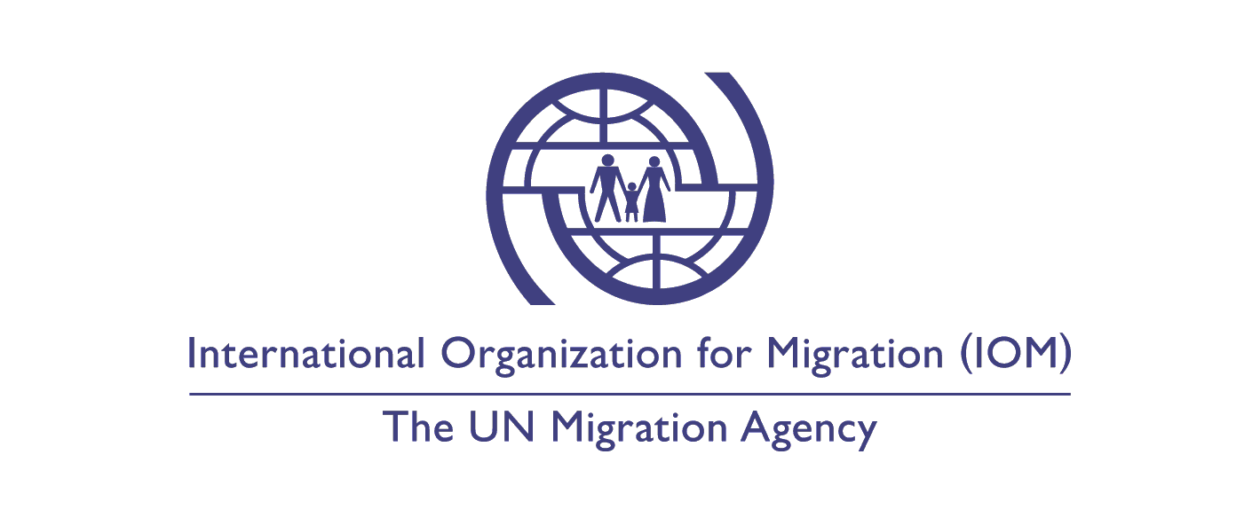
Call for Expression of Interest (EoI)
Position Title : Logistics and Procurement Assistant
Duty Station : IOM Accra, Ghana

Classification : Grade - UG
Type of Appointment : Special short-term ungraded, Six months with possibility of
extension
Estimated Start Date : As soon as possible
Closing Date : 20 December 2019

Established in 1951, IOM is a Related Organization of the United Nations, and as the leading UN agency in the field of migration, works closely with governmental, intergovernmental and non-governmental partners. IOM is dedicated to promoting humane and orderly migration for the benefit of all. It does so by providing services and advice to governments and migrants.

Context:

Under the overall supervision of Chief of Mission (CoM) and direct supervision of the Resource Management Officer (RMO), the Logistics/Procurement Assistant will support all Logistics/Procurement related activities in Ghana. Specifically, the Logistics/Procurement Assistant is responsible for the following functions:

Core Functions / Responsibilities:

- Assist in the management of the organization assets, perform periodic inventory counts and report any discrepancies to RMO.
- Liaise with the Senior Logistics and Procurement Assistant regarding procurement requests and requirements and consolidate them.
- Verify the Purchase Requisition Forms submitted to Procurement Unit for completeness; regarding needful signatures, WBS/s and the final authorization of the project manager, RMO and CoM.
- Assist in collecting quotations, preparing bids analysis, processing Purchase Requisitions and payment requests.
- Identify vendors and participate in the evaluation of them against performance, reliability, quality, price, delivery in respect of organizations’ best interests and donor mandates. Taking under consideration while conducting a bidding process, the value of money, quality, compatibility, payment method, warranty, after selling services, and the company profile / reputation.
- Assist in the management of IOM fleet and maintain the relevant documentation.
- Follow-up on purchase orders status and keep customers abreast of estimated time of delivery or any changes that may affect or modify the pre-determined delivery conditions.
- Ensure through established procedures, that all received goods/works/services are in accordance with the terms and specifications of the respective PO/Contracts.
- Ensure that the “Goods Receipt Notes” are acknowledged by the Requisitioner when the services/works are rendered and/or the goods are received.
- Submit with supporting documentation Payment Requests to the Finance Unit to execute in-Mission Payments. Follow up with the Finance Unit to ensure that suppliers’ accounts are settled on time.
- Archiving system update and management with proper labels for assets. Ensure that all procurement files are accurately documented and arranged for secure and systematic filing of all logistics related documents, contracts, etc.
- Conducting outdoor activities when necessary for checking prices, collecting bids, handing over the commodities to the beneficiaries, etc.

Undertake any other duties within the incumbent’s capabilities that might be assigned.

Required Qualifications and Experience:

Education

- Bachelor’s degree in business administration, Logistics, supply chain management, or any other related fields, with 1 (one) year of relevant professional experience. Or,
- High School Degree with minimum 3 (three) years of relevant professional experience.

Experience
- Interfaces across units and departments within IOM to extract relevant information.
- Communicates clearly and consistently.
- Effectively applies specialized knowledge of logistics and procurement to timely source goods and services.
- Effectively works with vendors and service providers in compliance with IOM procedures to secure cost-effective quality solutions for IOM.

Languages

For this position, fluency in English is required (oral and written). Working knowledge of French is an advantage.
1 Accredited Universities are the ones listed in the UNESCO World Higher Education Database (https://whed.net/home.php).

Required Competencies:

Values - all IOM staff members must abide by and demonstrate these three values:

- Inclusion and respect for diversity: respects and promotes individual and cultural differences; encourages diversity and inclusion wherever possible.
- Integrity and transparency: maintains high ethical standards and acts in a manner consistent with organizational principles/rules and standards of conduct.
- Professionalism: demonstrates ability to work in a composed, competent and committed manner and exercises careful judgment in meeting day-to-day challenges.

Core Competencies – behavioural indicators

- Teamwork: develops and promotes effective collaboration within and across units to achieve shared goals and optimize results.
- Delivering results: produces and delivers quality results in a service-oriented and timely manner; is action oriented and committed to achieving agreed outcomes.
- Managing and sharing knowledge: continuously seeks to learn, share knowledge and innovate.
- Accountability: takes ownership for achieving the Organization’s priorities and assumes responsibility for own action and delegated work.
- Communication: encourages and contributes to clear and open communication; explains complex matters in an informative, inspiring and motivational way.

IOM’s competency framework can be found at this link.

https://www.iom.int/sites/default/files/about-iom/iom_revised_competency_framework_external.p df

Competencies will be assessed during a competency-based interview.

Other:

The appointment is subject to funding confirmation.

Appointment will be subject to certification that the candidate is medically fit for appointment or visa requirements and security clearances.

No late applications will be accepted.

How to apply:
Interested candidates are invited to submit their applications directly to accravacancies@iom.int by 20 December 2019 at the latest, referring to this advertisement.

Only shortlisted candidates will be contacted.

Posting period:
From 06.12.2019 to 20.12.2019

No Fees:
IOM does not charge a fee at any stage of its recruitment process (application, interview, processing, training or other fee). IOM does not request any information related to bank accounts.

