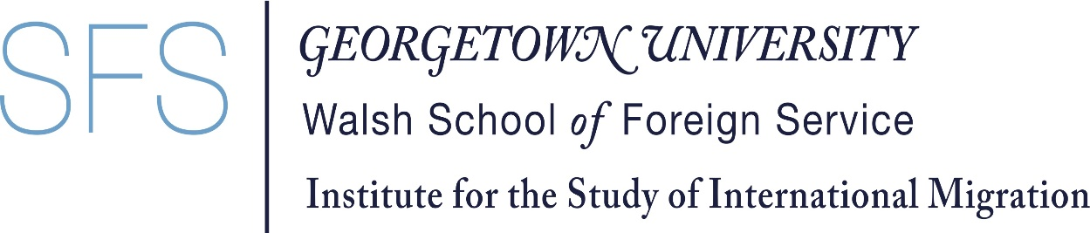

Intergovernmental Dialogue on Migration
Panel 2. Understanding the linkages between migration, environment and climate change and migration health
26 May 2021 (9-10.30 EST)
Elizabeth Ferris, Research Professor
Institute for the Study of International Migration
Georgetown University
Washington, DC
Elizabeth.ferris@georgetown.edu

Thank you for the opportunity to speak with you today on the important issue of the linkages between migration, environment and climate change and migration health in the context of COVID-19. As an academic researcher, I want to express appreciation for IOM’s wonderful work in supporting and disseminating research on both the impact of COVID-19 through its COVID-19 Analytical Snapshots, webinars, policy papers and issue briefs as well as its environmental migration portal. The work you do in collecting and disseminating evidence probably doesn’t get enough recognition in forums like this, so I want to begin by saying thank you.
In my brief remarks, I want to focus on the lessons that the COVID-19 pandemic offers to our thinking and our actions on climate-induced mobility.
Like covid-19, climate change is a global crisis that affects everyone on the planet. One of the themes of last year’s IDM and constantly emphasized by the UN Secretary-General is that no one is safe until everyone is safe. We live in an interconnected world where actions taken in one country can have repercussions in countries across the globe. This is true of pandemics and it is true of climate change. Our still-evolving experiences with the pandemic offer lessons for confronting climate change – and particularly the likelihood that the effects of climate change will increase the movement of people. In spite of alarming projections about the potential scale of these movements – most of which will be internal, rather than cross-border -- this does not have to be a crisis.
Global risk require global solutions. Governments have to work together to address global threats. As the Independent Commission on Pandemic Preparedness recently reported, the panel “found weak links at every point in the chain of preparedness and response. Preparation was inconsistent and underfunded. The alert system was too slow – and too meek. The World Health Organization was under-powered. The response has exacerbated inequities. Global political leadership was absent.” For at least the past decade there have been warnings that the effects of climate change will lead to large-scale population movements. We are already seeing increased movement of people due to the effects of climate change, both the increasing frequency and severity of sudden-onset disasters and the relentless effects of slow-onset hazards. People are moving now because of climate change and are likely to move in far greater numbers in the future.
This is not a crisis. People have always moved because of environmental change. Migration can be a form of adaptation to the effects of a changing climate. But just as the fact that the world was unprepared for the spread of the coronavirus, so too we are unprepared for large-scale movements of people due to the effects of climate change. Experts expect most people to move within the borders of their countries and especially to urban areas.
Many international agencies, including IOM and the World Bank, governments and many academics and civil society actors are already engaged in making predictions and recommendations about the scale and characteristics of climate change-induced mobility. But there is little coordination between these efforts. We need more global cooperation to pull these efforts together, to offer sound guidance to governments and to develop multilateral tools that can respond to the challenges of increased migration due to the effects of climate change. These disparate efforts – important as they are – presage an ad hoc response to climate migration.
We should heed the experiences of the pandemic these past 18 months – particularly the the importance of relying on science and of educating the public to counter misinformation and even denialism.
One of the effects of the pandemic has been its disproportionate effects on women, marginalized groups, migrants. We have seen increasing stigmatization and xenophobia. So too climate change is likely to affect vulnerable groups, people living in marginal areas, indigenous communities. We have seen that COVID-19 has led to increased vulnerability in environmentally fragile areas – which are also often areas affected by conflict, poverty, high rates of forced displacement and weak health systems. It has also increased the vulnerability of so-called ‘trapped populations’ – people unable to move. This is also a likely effect of climate change as the UK’s Foresight report warned us a decade ago.
There are other lessons that the pandemic offers us as we confront the reality of climate-induced migration. Global pandemics and climate change both impact people’s livelihoods – with devastating consequences for both individuals and for societies. As Bill Gates has written, climate change can be just as deadly as the pandemic and the economic costs could be far higher.
It is, of course, always easier to mobilize a massive response to a crisis once it occurs. It is more difficult to put into place systems to reduce the risk of disasters – whether they are pandemics, wars or climate change. But as the former executive secretary of the UNFCCC, Christiana Figueres remarked, the current crisis can encourage systemic changes and highlight the need to focus on prevention, support the most vulnerable and trust science-based solutions which will enable us to more effectively address the challenges of climate change migration. We still have time now to take actions which will prevent climate change migration from becoming a global crisis.
To close with the words of the Independent Panel on Pandemic Preparedness, “we have been warned.”

