High Level Regional Roundtable

“Social and Economic Impact of Migration:
Migrant vulnerabilities and integration needs in Central Asia”

Concept Note

Purpose and Theme of the High Level Roundtable

The purpose of the meeting is to strengthen the capacity of participating government and non-government stakeholders in the sphere of addressing the complex challenges related to irregular migration, labour migration, trafficking in persons and migrants’ rights in Central Asia, and the broader region, through sharing good practices, analysing emerging trends, identifying gaps and providing recommendations. The event is organized within the framework of the IOM program “Addressing Mixed Migration flows in Central Asia through capacity building” Phase II (2015-2016) funded by the Government of the United States (BPRM-PIM).

The Regional Roundtable will be held in Astana, Kazakhstan and it is co-organized by the International Organization for Migration (IOM) sub-regional coordination office for Central Asia and the Library of the First President of Kazakhstan (Nazarbayev Center).

The overall objective of the meeting is to support States to address complex migration challenges into, within and out of Central Asia and the broader region. To achieve this, the meeting will:

- Explore the driving forces of human mobility and labour migration (including irregular) in Central Asia and the broader region and discuss how the factors such as conditions of migrants’ integration; protection of migrants’ rights and preventing exploitation; remittances and others can contribute to the economies, societies and the environment. The meeting will also aim at identifying the regional impact of the re-entry bans of migrant workers to the Russian Federation, as well as the effect of the Eurasian Economic Union’s (EAEU) enlargement.

- Discuss the linkage between development, migration and migrants’ rights. Explore relevant global legal framework and its implications on regional and national levels.

- Share good practices on migration governance including administrative, legislative and operational reviews recognizing the linkages between migration and development. Particularly the discussion will be focused on good practices in: (a) regulating labour markets for facilitating immigration of priority groups; (b) provide legal opportunities in seasonal work and cross-border commerce through improvement of work permit procedures and (c) utilizing remittances for achieving development.

- Identify gaps in mechanisms for protecting migrant workers’ rights, with reference to international law and standards, and propose solutions that will (a) better prepare emigrants for integrating in receiving societies as well as return migrants reintegrating into the labour market of countries of origin; (b) protect employment and social security rights of migrants; and (c) improve compliance by employers with the rules for foreign work.

- Share good practices in countering trafficking in persons in, within and out of Central Asia and the broader region.

- Explore the potential for cooperation between relevant bodies of Central Asian states and the broader region so as to facilitate inter-state mechanisms to co-ordinate migration processes and share statistics and operational data that will allow to better understand and manage immigration flows.

- Provide recommendations to address gaps and challenges related to human mobility and labour migration in Central Asia and the broader region.

Background on the Theme

Human mobility and Labour migration is a trans-national process, and inter-state cooperation is essential for managing it properly. The success of the migratory experience will depend not only on the migrant’s capacity to face the challenges of his or her new situation, but also on the approaches taken in the management of migration by both sending and receiving countries. Recent studies suggest that policymakers need to look beyond their own borders when formulating national migration laws and procedures. They need also to anticipate the consequences of other states’ simultaneous attempts to regulate immigration.

With the adoption of the Sustainable Development Goals (SDGs) in September 2015 for the 2030 Agenda for Sustainable Development, the international community agreed on the priority development goals till 2030, ways to reach them and indicators to evaluate the success. Already in the early 2000s migration was recognized as a significant factor for development, acknowledged by the High Level Dialogue on Migration (HLD) in 2006 which set the basis for global forums on migration and development. The milestone second HLD adopted the declaration recognizing inter alia the importance to uphold and protect the rights of migrants. Today’s post-2015 sustainable development Agenda maintains such recognitions, with a strong reference to migration management issues. As for the way the goals will be achieved, a lot depends on the implementation of the international law which provides the basis for the development and the implementation of regional and national laws in the area of migration. Specifically national laws regulating labour migration, the status of migrant workers, their protection, counter trafficking related issues, the authority and the responsibility of states in migration management acquire particular importance.

Migrant workers from Central Asia and the broader region in search for job opportunities have managed to cope with imbalances on the local labour market and periodic economic downturns. The primary “push” factor for labour emigration is economic. In turn, the key “pull” factor is sociocultural. Countries experiencing positive economic growth (like Kazakhstan) are also in high demand for workers especially given the challenge of sectoral shortages and brain drain observed recently. To minimize the disruptive effects of emigration, authorities in Central Asia and the broader region need to identify the specific factors influencing the flows of various categories of migrants and apply a combination of instruments, ranging from information campaigns through legal advice to support for orientation in the local labour market. A proper mix of targeted measures is needed to counteract such problems as de-skilling or adaptation difficulties.

Economic hardship and insufficient development opportunities in the home regions continue to fuel labour migration in, within and out of Central Asia and the broader region. The irregular status of employment of nationals from Central Asian and the broader region puts them at increased risk of fraud, wage theft, abuse, deportation, health risks, loss of economic livelihood and insecurity for family members. Migrant workers, regular or irregular, may also be more susceptible to becoming victims of smuggling or trafficking by criminal or radicalised extremist groups. It is therefore indispensable for participating states to share experiences in assisting migrants at all stages of their movement: supplying

information prior to their departure; integrating them in receiving societies; protecting their employment and social security rights in the destination country as well as reintegrating them into the labour market on returning to countries of origin.

Remittances are an important source of income for households, particularly in developing countries, like Tajikistan and Kyrgyzstan. Remittances have been identified as the third pillar of development as their volume is second to foreign direct investment and higher than overseas development assistance. For Central Asia and the broader region remittances provide a great share of the foreign direct investment contributing to poverty reduction and development. In 2013, 48.1% of Tajikistan’s GDP and 31.4% of Kyrgyzstan’s GDP came from remittances. Pakistan is the 2nd among South Asian nations sending migrant workers abroad and describes itself as a country highly pro-emigration. It is therefore very important for participating states to have a solid and clear policy to support overseas employment that will facilitate remittances. At the same time remittances can be the source of financing criminal activities that requires particular attention and collective action in dealing with problems of countering various security threats.

Russia’s recent economic crisis has directly resulted to reduced remittances rates, worsening the standards of living in remittance-receiving countries. According to World Bank, remittances from Russia to Tajikistan fell 8% in 2014 and were expected to decline another 23% in 2015. In Uzbekistan, they fell 16% and were expected to drop another 30% in 2015 while in Kyrgyzstan they fell by 1% but were expected to drop another 23% this year. Within this context the impact of the application of bans had on the total level of remittances and which categories of migrants have been most affected needs to be analyzed in a comprehensive manner.

The IDF report ”Mapping on Irregular Migration in Central Asia 2014” , published by IOM Central Asia in 2015, identified as a key regional issue in the area of migration management the need to re-integrate in the countries of origin the migrant workers, subject to re-entry bans in Russia. This issue was also recognized as an area of immediate concern by the migration officials from the five Central Asian countries (Kazakhstan, Kyrgyzstan, Tajikistan, Turkmenistan and Uzbekistan), participating in the IOM-run regional training focused on irregular migration, which took place in March/April 2015 in Almaty.

Building further on the IDF report, IOM Central Asia launched a dedicated field (rapid) assessment on "Returning Central Asian Migrants: between radicalization and re-integration” (August-October 2015), which looked into some of the vulnerabilities of re-entry banned migrants. In the course of interviews with migrants, experts and officials as well as focus groups with Central Asian migrant workers, preliminary conclusions were drawn as to the circumstances, in which some of the re-entry banned migrants might be at risk of economic deprivation, social isolation and become prone to religious radicalization.

Preliminary findings of the assessment established that the application of re-entry bans in the Russian Federation has had strong impact on the well-being of a significant part of the migrant workers and their families and communities in Central Asia. Coupled with the devaluation of the rouble and the contraction of the Russian economy, introduction of the more stringent rules for entry and exit put additional pressure on many migrants to return to the country of origin or find alternative destinations. The introduction of measures easing access to seasonal employment has made Kazakhstan an attractive labour market for some migrants from other Central Asian states. However, the majority of interviewed re-entry banned migrants have not been aware of the opportunities for legal employment within the Central Asian region. As some of them do not know their exact legal status in Russia, they run the risk of seeking to re-enter that country without authorization, and finding themselves subject to longer ban

periods. In turn, many returning migrants find it difficult to adjust to the different labour market conditions in their countries of origin, which may result in prolonged joblessness or irregular work.

While experts agree that migrants returning to Central Asia as a whole are not a target group for radical propaganda, the fragile socioeconomic situation may make them more some of them vulnerable to radical religious ideologies. In particular, those among them who face integration difficulties and lack sufficient suport from their community are more likely to develop a radical worldview when they are in the environment, in which radicals occupy positions of authority and pursue direct recruitment strategies. The field assessment confirmed that migrants become radicalized primarily outside of the Central Asian region and so far there has been little immediate security threat coming from their return. However, the States have expressed a concern about the linkage between the activities and objectives of extremist groups outside the region with those of the existing radical groups, operating in Central Asia and in Afghanistan. Interviews with officials in Kazakhstan and Kyrgyzstan have revealed a number of good practices for countering radicalization, including the raising of quality of religious education, awareness-raising activities targeting the most vulnerable groups and sanctions against persons with links to ISIS or other extremist/radical groups.

The results of the assessment were presented at the 2nd Senior Officials’ Meeting (SOM) of the Almaty Process in Astana in September 2015. In the wake of the assessment , it was resolved that the nexus between re-entry banned migrants, socioeconomic factors and religious radicalization should be explored in greater depth under a more extended regional assessment/study. The High Level Regional Roundtable will be an opportunity for reviewing the methodology of the assessment.

Participants will also have the opportunity to share their migration management policy and legislation, experience with entering the Customs Union, effect of remittances and how they address the vulnerability of migrant workers; will also address whether legislation and practice is in conformity with international law, especially human rights law. The High Level Regional Roundtable will provide the opportunity to further discuss on gaps in policy and legislation, share good practises and develop recommendations as to how these challenges can be addressed.

Annex 1

Sustainable Development Goals (SDGs) relevant to international migration issues covered under the Regional Roundtable

SDG 4 – Quality Education

SDG 5 – Gender Equality

SDG 8 – Decent Work and Economic Growth

SDG 10 – Reduced Inequalities

SDG 16 – Peace, Justice, and Strong Institutions

SDG 17 – Partnerships for the Goals

Annex 2

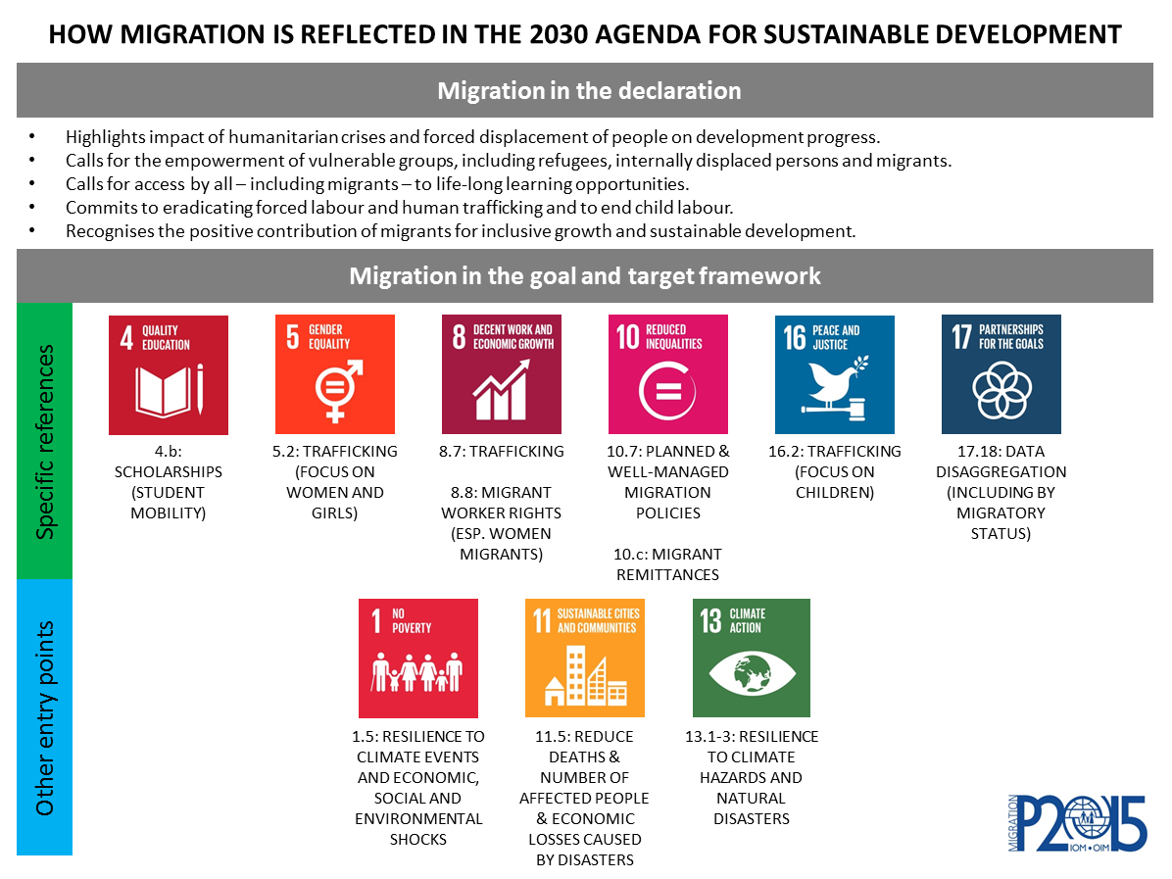

Source: https://unobserver.iom.int/2030-agenda-sustainable-development

IOM, Migration and Labour, Essentials of Migration Management, Volume 2: Developing Migration Policy
Economic and Social Research Council, How labour market regulation affects migration, August 2013.
The Sustainable Development Goals build on the Millennium Development Goals (MDGs), aiming to “complete what they [the MDGs] did not achieve”. See the UN Resolution adopted by the General Assembly on 25 September 2015, http://www.un.org/en/ga/search/view_doc.asp?symbol=A/RES/70/1.
IOM, Mapping on Irregular Migration in Central Asia 2015.
The World Bank “Migration and Remittance Flows in Europe and Central Asia: Recent Trends and Outlook” 2013-2016, p.15&16
ILO, Strengthening Labour Migration Governance in Pakistan, http://www.ilo.org/wcmsp5/groups/public/---asia/---ro-bangkok/---ilo-islamabad/documents/publication/wcms_241600.pdf
The World Bank: “Remittances growth to slow sharply in 2015, as Europe and Russia stay weak; pick up expected next year”. April 13, 2015. http://www.worldbank.org/en/news/press-release/2015/04/13/remittances-growth-to-slow-sharply-in-2015-as-europe-and-russia-stay-weak-pick-up-expected-next-year
The 2015 released IOM CA report http://www.iom.kz/publications , funded by the IOM Development Fund, “Mapping on Irregular Migration in Central Asia”, it was implemented on the request of the involved Governments and was written together and in close consultation/coordination with government stakeholders, IOM missions, international and national experts in the region. The report has been also extensively presented in cooperation with government stakeholders in different settings: international, CA regional and CA national events aiming to promote good international practices, increase regional cooperation and regional dialogue under the RCP “Almaty Process” http://www.iom.int/almaty-process and capture new trends in migration areas of mutual interest and concern.

