OFDA REHABILITATION PROJECT - SHELTER ASSESSMENT REPORT

(Critical Shelters and Damaged Houses)

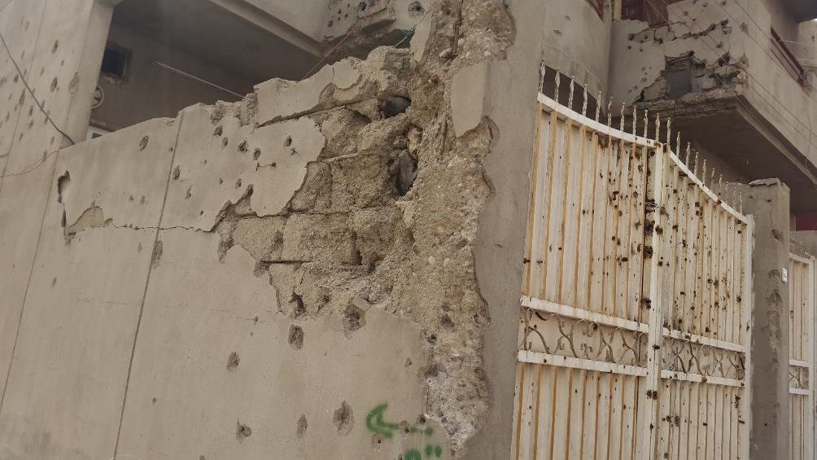

Item 1 pictures: Damaged Walls

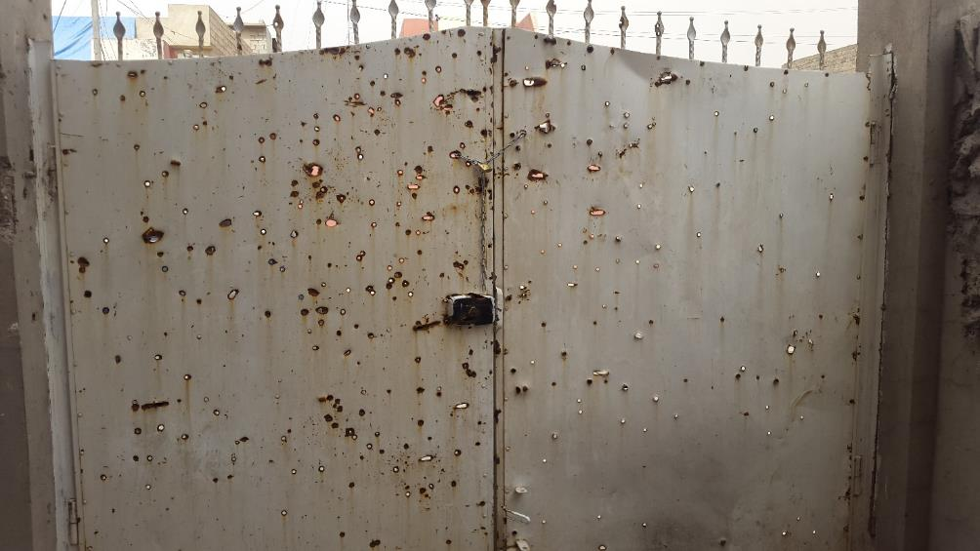

Item 2 pictures: Out Door

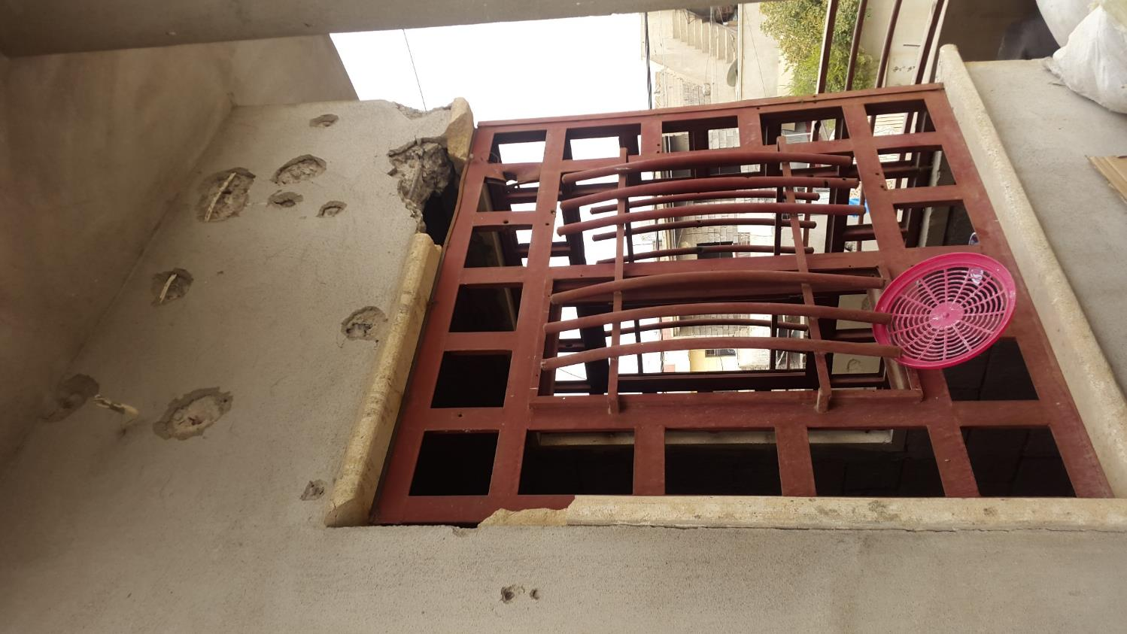

Item 3 pictures: Glass for Window
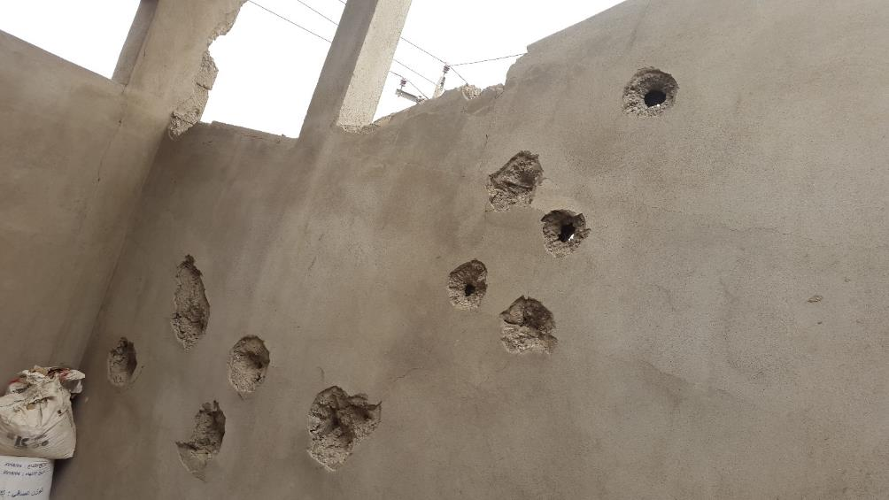

Item 4 pictures: Damaged Wall

