
FPU.SF-19.2
IOM Abyei, South Sudan

REQUEST FOR QUOTATIONS (RFQ)

AND

GENERAL INSTRUCTION TO SERVICE PROVISDERS (GIS)

To : Vehicle Hire companies in South Sudan.
Project : Vehicle Hire for IOM Abyei, South Sudan Operations on a Long-term Agreement Basis.
Ref. No.: ABYLOG213879
Date : October 19, 2021

The International Organization for Migration (IOM) is an intergovernmental organization established in 1951 and is committed to the principle that humane and orderly migration benefits both migrants and society.

IOM South Sudan invites interested Service Providers to submit RFQs/Quotations to engage Vehicle hire services for IOM Abyei South Sudan Operations on a Long-term Agreement Basis for a period of one (1) year with possibility of extension for one (1) or two (2) years subject to satisfactory performance.

RFQs/Quotations must be delivered by hand or through mail to IOM with office addresses at New Industrial Area Northern Bari, Juba, South Sudan or UNCP Camp, UNISFA Compound, Abyei South Sudan on or before November 15, 2021, 17.00 hours local time. No late Quotation shall be accepted.

With this RFQ is the GIS which includes the Instructions to Service Providers, Technical Specifications and administrative requirements that Service Providers will need to follow in order to prepare and submit their quotation for consideration by IOM.

IOM reserves the right to accept or reject any quotation, and to cancel the procurement process and reject all quotations at any time prior to award of Purchase Order or Contract, without thereby incurring any liability to the affected Service Provider/s or any obligation to inform the affected Service Provider/s of the ground for IOM’s action.

Very truly yours,
NIGO Taban Joel Emmanuel.
Procurement Staff/Focal Point

IOM is encouraging companies to use recycled materials or materials coming from sustainable resources or produced using a technology that has lower ecological footprints.

GENERAL INSTRUCTION TO SERVICE PROVIDERS (GIS)

- Description of Services

IOM requests prospective service providers to submit quotations for the provision of Vehicle hire services for IOM Abyei South Sudan Operations on a Long-term Agreement Basis for a period of one (1) year with possibility of extension for one (1) or two (2) years subject to satisfactory performance.

The vehicles should be as listed in the table below;
Item No. | Description | Model | Detailed Specs.
 | 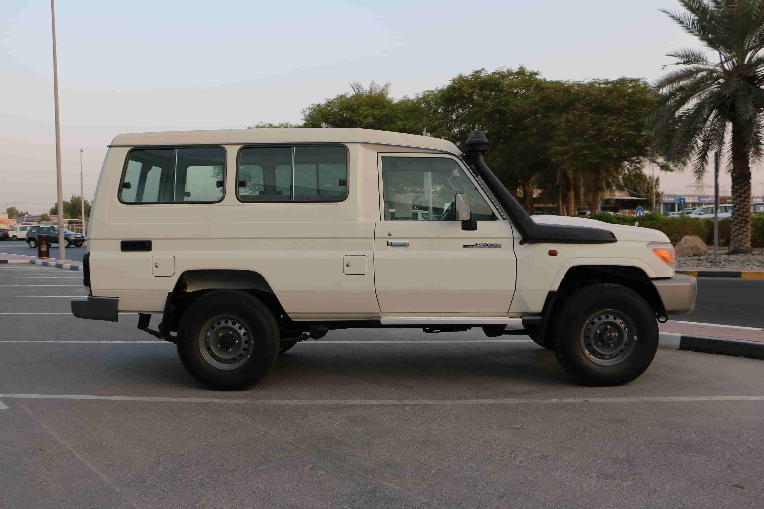  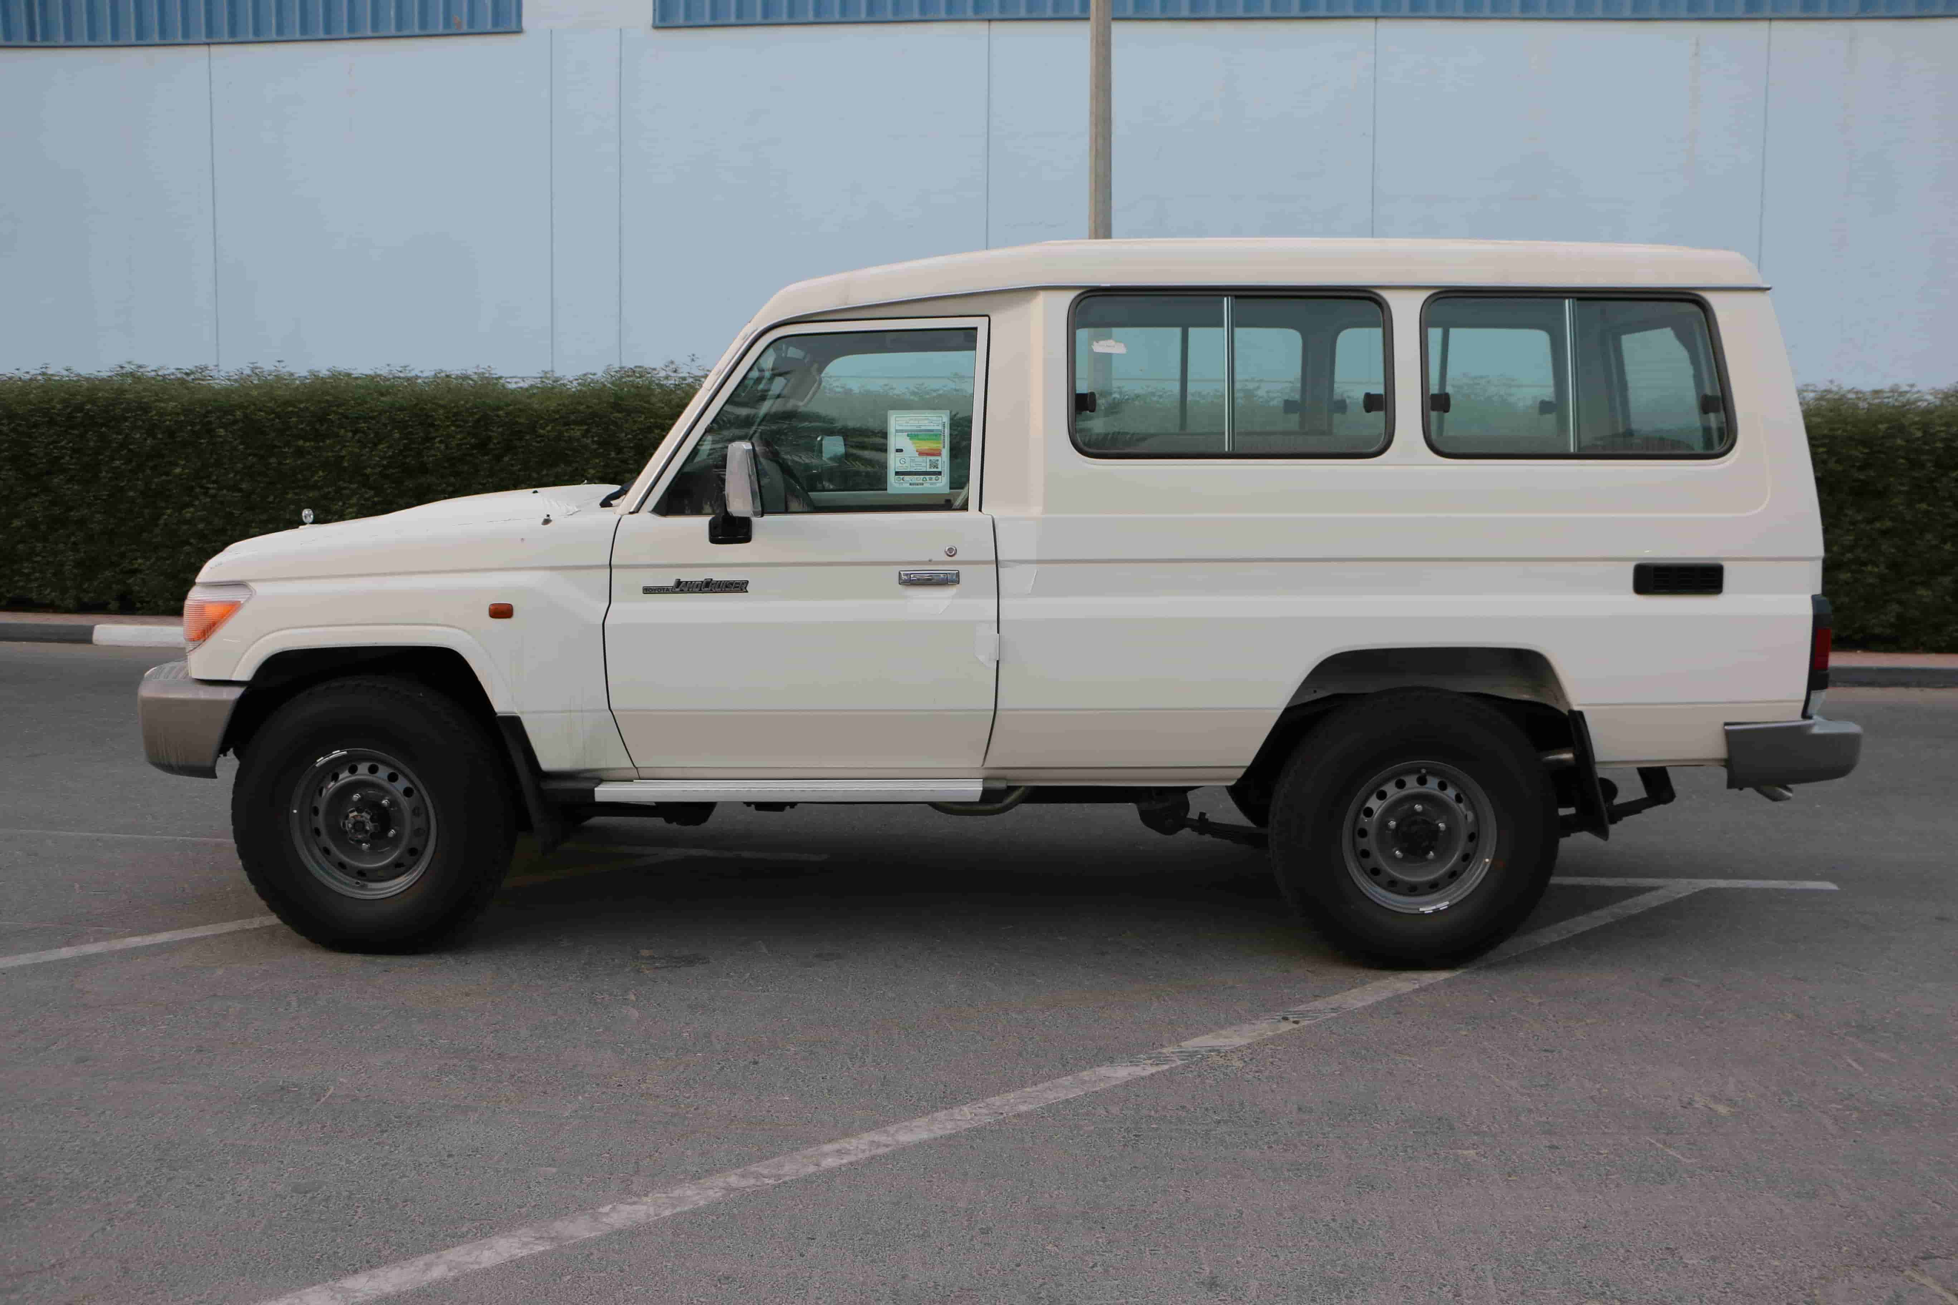  Toyota Landcruiser Hard top 3 doors (13-seater) | 2018 & above | 
 | Toyota Landcruiser Hard top 5 doors (10-seater)   | 2018 & above | 
 | 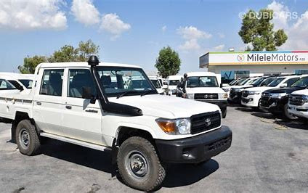  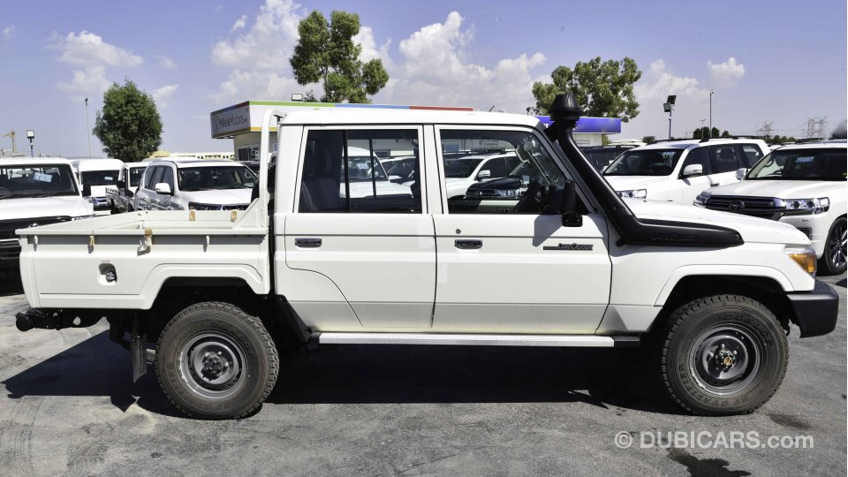  Toyota Landcruiser Double Cabin Pick-up (5-seater) | 2018 & above | 
 | Toyota Landcruiser Single Cabin Pick-up vehicle    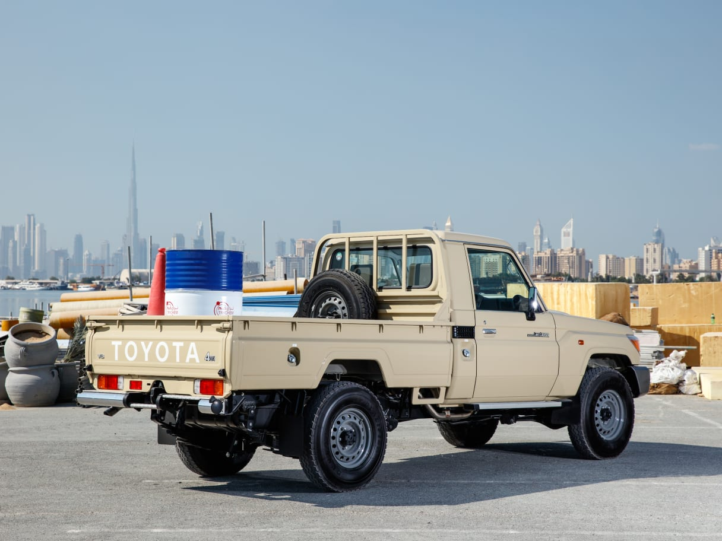 | 2018 & above | 

2. Corrupt, Fraudulent, and Coercive Practices

IOM requires that all IOM Staff, manufacturers, service providers, or distributors, observe the highest standard of ethics during the procurement and execution of all contracts. IOM shall reject any Quotation put forward by Service Providers, or where applicable, terminate their contract, if it is determined that they have engaged in corrupt, fraudulent, collusive, or coercive practices. In pursuance of this policy, IOM defines for purposes of this paragraph the terms set forth below as follows:

- Corrupt practice means the offering, giving, receiving, or soliciting, directly or indirectly, of any thing of value to influence the action of the Procuring/Contracting Entity in the procurement process or in contract execution.

        - Fraudulent practice is any act or omission, including a misrepresentation, that knowingly or recklessly misleads, or attempts to mislead, the Procuring/Contracting Entity in the procurement process or the execution of a contract, to obtain a financial gain or other benefit to avoid an obligation.

        - Collusive practice is an undisclosed arrangement between two or more bidders designed to artificially alter the results of the tender procedure to obtain a financial gain or other benefit.

        - Coercive practice is impairing or harming, or threatening to impair or harm, directly or indirectly, any participant in the tender process to influence improperly its activities in a procurement process or affect the execution of a contract.

3. Conflict of Interest
All Service Providers found to have conflicting interests shall be disqualified to participate in the procurement at hand. A Service Provider may be considered to have conflicting interest under any of the circumstances set forth below:

- A Service Provider has controlling shareholders in common with another Service Provider.

- A Service Provider receives or has received any direct or indirect subsidy from another Service Provider.

- A Service Provider has the same representative as that of another Service Provider for purposes of this quotation.

- A Service Provider has a relationship, directly or through third parties, that puts them in a position to have access to information about or influence on the Quotation of another or influence the decisions of the Mission/Procuring Entity regarding this quotation process.

- A Service Provider submits more than one Quotation in this Quotation process.

- A Service Provider who participated as a consultant in the preparation of the design or technical specifications of the Services and related services that are subject of this quotation process.

4. Eligible Service Providers
Only Service Providers that are determined to be qualified shall be considered for award. The Service Provider shall fill up and submit the standard IOM Vendor Information Sheet (VIS) (Annex E) to establish their eligibility together with the Quotation.

5. Cost of Preparing the Quotation
The Service Provider shall bear all costs associated with the preparation and submission of his Quotation and IOM will not in any case be responsible and liable for the costs incurred.

6. Errors, omissions, inaccuracies, and clarifications.

The documents and forms requested for the purpose of soliciting Quotations shall form part of the Contract; hence care should be taken in completing these documents.

Service Providers shall not be entitled to base any claims on errors, omissions, or inaccuracies made in the Quotation Documents.

Service Providers requiring any clarifications on the content of this document may notify the IOM in writing at the following address.

IOM Abyei office, located at UNISFA Compound or IOM Juba office located in the New Industrial Area, Northern Bari Payam, Juba County, 9999 via email addresses: tnigo@iom.int and issjp@iom.int

IOM will respond to any request for clarification received on or before November 8, 2021, 5:00 p.m. Copies of the response including description of the clarification will be given to all Service Providers who received this General Instruction, without identifying the source of the inquiry.

7. Confidentiality and Non-Disclosure

All information given in writing to or verbally shared with the Service Provider in connection with this General Instruction is to be treated as strictly confidential. The Service Provider shall not share or invoke such information to any third party without the prior written approval of IOM. This obligation shall continue after the procurement process has been completed whether or not the Service Provider is successful.

8. IOM’s Right to Accept any Quotation and to Reject any and all Quotations

IOM reserves the right to accept or reject any Quotation, and to cancel the procurement process and reject all Quotations, at any time prior to award of contract, without thereby incurring any liability to the affected Service Provider/s or any obligation to inform the affected Service Provider/s of the ground for IOM’s action.

9. Requirements

  - Quotation Documents
The following shall constitute the Quotation Documents to be submitted by the Service Providers:
a.) Quotation Form (Annex A)
b.) Price Schedule Form (Annex B)
c.) Technical Quotation Form (Annex C)
d.) Terms of Reference (Annex D)
d.) Vendor Information Sheet (Annex E)
e.) Proforma Contract or PO Standard Terms and Conditions (Annex F)
g.) Proforma Bank Guarantee for Advance Payment (Annex G)
h.) Supplier Code of Conduct (Annex H)

Service Providers are required to use the forms provided as Annexes in this document.

9.2 Quotation Form

The Quotation Form (Annex A) and other required documents shall be duly signed and accomplished and typewritten or written in indelible ink. Any correction made to the prices, rates or to any other information shall be rewritten in indelible ink and initialed by the person signing the Quotation Form.

The language of the Quotation shall be in English and prices shall be quoted in USD, exclusive of VAT.

Prices quoted by the Service Provider shall be fixed during Service Provider performance of the contract and not subject to price escalation and variation on any account, unless otherwise approved by IOM. A submitted quotation with an adjustable price quotation will be treated as non-responsive and will be rejected.

9.3 Validity of Quotation Price

The Quotation shall remain valid for a minimum period of 60 calendar days, after the deadline for submission.

In exceptional circumstances, prior to expiry of the period of validity of quotations, IOM may request that the Service Providers extend the period of validity for a specified additional period. The request and the response there to shall be made in writing. A Service Provider agreeing to the request will not be required or permitted to modify its quotation.

9.4 Documents Establishing Service Provider’s Eligibility & Qualification

The Service Provider shall furnish, as part of its Quotation, documents establishing the Service Provider’s eligibility to submit Quotation and its qualifications to perform the contract if its Quotation is accepted. The IOM’s standard Vendors Information Sheet (Annex D) shall be used for this purpose.

In the case of a Service Provider not doing business within the Mission’s country, the Service Provider is or will be (if awarded the contract) represented by an Agent in that country equipped and be able to carry out the Service Provider’s maintenance, repair and spare parts-stocking obligations prescribed in the Conditions of Contract and/or Technical Specifications.

10. Submission of Quotation Documents
Quotation must be submitted in a sealed envelope. The Service Provider must seal the original and copy of the Quotation Documents as stated in item 9.1 (Quotation Documents) and shall be addressed to IOM Abyei office, located at UNISFA Compound or IOM Juba office located in the New Industrial Area, Northern Bari Payam, Juba County, 9999.

Quotations shall be submitted by hand delivery to the above addresses on or before November 15, 2021, by 5:00 p.m. Late Quotations will not be accepted.

11. Opening of Quotations.

At the indicated time and place, the opening of Quotations shall be carried out by IOM Bids Evaluation and Awards Committee. IOM reserves the right to conduct opening of Quotations in public or not.

12. Acceptance of Quotations.
IOM is not bound to take an immediate decision on the acceptability or unacceptability of Quotations at the time of their opening.

13. Rejection of Quotations
Quotation can be rejected for the following reasons:

(a) the Quotation is not presented in accordance with this General Instruction.
(b) the Quotation Form or any document which is part of the Quotation
Document is not signed.
(d) the Service Provider is currently under list of blacklisted Service Providers.
- the Service Provider’s offer imposes certain basic conditions unacceptable to IOM
- the offered price is above the approved budget (delete if not applicable)

IOM is not bound to accept any offer received and reserves the right to waive any minor defect in an offer, provided, however, that such minor defect (i) does not modify the substance of the offer and (ii) does not change the relative ranking of the Service Providers.

14. Evaluation of Quotations

IOM shall evaluate and compare the Quotations based on the following:

- Completeness and responsiveness of the documents mentioned in 9.1
- Compliance with technical specifications including delivery requirement
- Price

Arithmetical errors will be corrected on the following basis. If there is a discrepancy between the unit price and the total price that is obtained by multiplying the unit price and quantity, the unit price shall prevail, and the total price shall be corrected. If the Service Provider does not accept the correction of the errors, its Quotation will be rejected. If there is a discrepancy between words and figures, the amount in words will prevail.

15. Post Qualification

Prior to award, post-qualification will be carried out by IOM to further determine the selected Service Provider’s technical and financial capability to perform the contract. IOM shall verify and validate any documents/information submitted and shall conduct ocular inspection of the office, plant and equipment.

16. Award of Contract
The Service Provider that submits the lowest evaluated Price, substantially responsive to the requirements of this General Instruction and who has been determined to be qualified to perform the contract shall be selected and awarded the contract.

IOM shall notify the selected service provider through a Notice of Award. IOM shall also notify in writing, the other Service Providers who were not selected without disclosing the reason for rejection.

17. Delivery Site and Period of Delivery
The services should be provided in the locations outlined in the delivery schedule of the technical Quotation form TQF 3.3 below

Delivery period shall be within 24 hours upon signing of the Purchase Order or Contract.

18. Liquidated Damages

If the Service Provider fails to provide any or all of the services within the period specified in Clause 17 above, a penalty payment of 0.1% of the price of the undelivered Services for every day of breach of the delivery schedule by the Service Provider will be requested.

19. Payment
Payment shall be made only upon IOM’s acceptance of the Services, and upon IOM’s receipt of invoice describing the Services delivered.

IOM may grant an advance payment equivalent to maximum of 10% to 15% of the Contract Amount upon submission of a claim and a Bank Guarantee for the equivalent amount valid until the Services are delivered and, in the form, provided in Annex E. The bank guarantee may be waived if the advanced amount is less than USD Five Thousand Dollars (USD5,000).

20. Warranty

Warranty shall be quoted based on the standard warranties provided by the manufacturer unless specified in the Technical Specifications of this General Instruction. A Warranty Certificate shall be provided by the Service Provider.

21. Settlement of Dispute

The United Nations Commission on International Trade Law (UNCITRAL) arbitration rules will apply for any dispute, controversy or claim that will arise in relation to the procurement process.

Annex A

QUOTATION FORM

Date : _______________________

To : _______________________
_______________________
_______________________

Having examined the General Instruction for the provision of Vehicle hire services for IOM Abyei, South Sudan Operations on a Long-term Agreement Basis, the receipt of which is hereby duly acknowledge, I, representing [name of company] offer to provide the requested services in conformity with the General Instruction for the total amount of [total bid amount in words and figures and currencies] in accordance with the Price Schedule (Annex B) which is herewith attached and form part of this Quotation.

I undertake if my offer is accepted, to provide the services in accordance with the delivery schedule set out in the Technical Quotation below.

I agree to abide by this Quotation for the Validity Period specified in the General Instruction which may be accepted at any time before the expiration of that period.

Until a formal contract is prepared and executed, this Quotation Form, together with your Notice of Award shall constitute a binding agreement between us.

I hereby certify that this Quotation complies with the requirements stipulated in the General Instruction.

Dated this______________ day of____________20_____.

________________________ ________________________________
[signature over printed name] [in the capacity of]

Duly authorized to sign Quotation for and on behalf of
____________________________________ [name of company]

Annex B

PRICE SCHEDULE FORM

PROJECT TITLE : ____________________________
LOCATION : ____________________________
REF NO. : ____________________________

# | State | County | Vehicle Type Required | Unit Price (Per Day), USD | Unit Price (Per Month), USD
LOT 1 | Abyei Area | Rumamer, Agany, Mabok rer, Athony, Kadian, Awal, Yuager, Marengdil, Marial Achak, Leu, Mabok, Mijak Hq, Dungop, Tajalei, Machbong, Makeui Wun, Lut Angok, Abyei (Mulmul & Ameth-Bek) Kolom, Noong, Dokura, Amiet, Rumbek, Rubjaba, Malual wur, Wunpeth, Wawacen, Nyijong, Miyom Gok  Nyagung, Gailum, Gungkuel, Rumakuoch, Guongchol, Moitoch, Majok Aleu, Mithiang Anguoi Deng, Mithiang Wunachai, Mabior  Achol Wunaraan, Mane Ajiing, Agigiguel, Gakyom, Wunchei, Magar, Anyac, Nyiel, Mangok, Achuk, Miyen Achok, Kolnuer  Miyeng-Jerdel, Rumgok, Juljok  Agok el Matar, Mabun North, Mabun South, Mading Jong, Thiang Koluoth, Mijak Kol  Rumjong, Maker Aniet, Maker Awetwet, Akechinail, Miyang  Agack, Nyinakwac, Minyrok, Gongbial, Miokol, Abathok, Makuei wut, Jongyom, Bachop, Abyeithony, Gokmou, Doup  Wundop, Thigei, Alal, Dahlop, Andel, Kec, Langar, Umkeir  Todach, Kol-thiou/sink, Umkaraith, Dak-Jur, Athai, Agok  Rumbek-Rumjaba, Malual Aleu, Mijak, Miodol, Mading Achueng, Agany Tok, Wunrok, Maker, Shegeg, Umkharite, Goli, Dumboloya, Diffra, Farouk, Mekines, Daira | Toyota Land Cruiser Hardtop (3 & 5 doors vehicles) and Toyota Land Cruiser Pick-ups (Single and Double Cabins)

__________________________________________
Service Providers authorized signature over printed name
Annex C
TECHNICAL QUOTATION

TQF-1: Technical Quotation Submission Form

[Location, Date]

To: BEAC, IOM South Sudan
New Industrial Area, Northern Bari, Juba, South Sudan

Ladies/Gentlemen:

We, the undersigned, offer to provide the Services for Vehicle Rent for IOM South Sudan Operations on a Long-term Agreement Basis in accordance with your Request for Quotations (RFQ) dated November 3, 2021. We are hereby submitting our Quotation, which includes this Technical Quotation, and a Financial Quotation.

If negotiations are held after the period of validity of the Quotation, we undertake to negotiate on the basis of the proposed staff. Our Quotation is binding upon us and subject to the modifications resulting from Contract negotiations.

We acknowledge and accept IOM’s right to inspect and audit all records relating to our Quotation irrespective of whether we enter into a contract with IOM as a result of this Quotation or not.

We understand you are not bound to accept any Quotation you receive.

We remain,

Yours sincerely,

Authorized Signature:
Name and Title of Signatory:
Name of Firm:
Address:

TQF-2: Service Provider’s Organization

Name of Bidder: | [Insert Name of Bidder] | Date: | Select date
RFQ reference: | ABYLOG213879, Vehicle hire for IOM South Sudan Operations on a Long-term Agreement Basis

Eligibility Declaration (Bidder submitted the following)
Certifications, Licenses, and Insurances – all documents required under Article 5.3 of the Section IV. of RFQ | ☐ Yes ☐ No
Company (as well as any parent, subsidiary, or affiliate companies) is not listed in, or associated with a company or individual listed in the Compendium of United Nations Security Council Sanctions Lists (https://www.un.org/sc/suborg/en/sanctions/un-sc-consolidated-list) | ☐ Yes ☐ No
Company (as well as any parent, subsidiary, or affiliate companies) is not currently removed or suspended by the IOM or any other United Nations agency (including the World Bank); | ☐ Yes ☐ No
Company has not declared bankruptcy, are not involved in bankruptcy or receivership proceedings, and there is no judgment or pending legal action against your company that could impair your company's operations in the foreseeable future; | ☐ Yes ☐ No
Company undertakes not to engage in proscribed practices (including but not limited to: corruption, fraud, coercion, collusion, obstruction, or any other unethical practice), with the UN or any other party, and to conduct business in a manner that averts any financial, operational, reputational or other undue risk to the IOM; | ☐ Yes ☐ No
Quotation is presented in accordance with this General Instruction; | ☐ Yes ☐ No
Bidder completed at least 2 contracts of similar nature, volume, complexity and value in the past 3 years. | ☐ Yes ☐ No

Company Profile
1.1 Brief Description of Bidder as an Entity: Provide a brief description of the company, its legal mandates, authorized business activities, the year and country of incorporation, and approximate annual budget, etc. include reference to reputation, or any history of litigation and arbitration in which the company has been involved that could adversely affect or impact the delivery of Services and/or performance of related services, indicating the status/result of such litigation/arbitration.

Maximum 2 pages or attach in a separate document

1.2 Financial Capacity: Based on the latest Audited Financial Statement (Income Statement and Balance Sheet) describe the financial capacity (liquidity, stand-by credit lines, etc.) of the bidder to engage into the contract. Include any indication of credit rating, industry rating, etc. Audit Reports for the last three (3) years.

Maximum 1 page or attach in a separate document

1.3 Previous Relevant Experience
Please list previous similar assignments successfully completed in the last 5 years. List only those assignments for which the Bidder was legally contracted. The Bidder should be prepared to substantiate the claimed experience by presenting copies of relevant documents and references if so, requested by IOM.

Project name & Country of Assignment | Client & Reference Contact Details | Contract Value | Period of activity and status | Types of activities undertaken
☐ Attached are the Statements of Satisfactory Performance from the Top 3 (three) Clients or more.

1.4 Qualifications/Expertise of Key Personnel proposed for the assignment
Please use TFP-3.1 Team Composition and Task Assignments to provide information regarding the key professional staff (drivers, manager) proposed for the assignment. Provide the CVs, certificates, licenses, and other information deemed necessary to demonstrate expertise of the proposed staff.
☐ Attached are the personnel CVs, certificates, licenses etc.

1.5 Fleet Summary
Provide a summary of the company’s complete fleet and indicate number of vehicle (how many vehicles owns the Bidder), vehicle type, brand, year of production, mileage reading, technical conditions, current location of the vehicle etc.
☐ Attached are copy of technical documentation including passport, inspection certificates and insurance policies, ownership documents for each proposed vehicle.

TQF – 3.1: Team Composition and Task Assignments

1. Proposed drivers
Name and Surname | Number of Years in Company | Overall experience as a driver

*Copy of driving license, CV, qualification documents and insurance policy must be submitted for each proposed driver

TQF – 3.2: Proposed motor vehicles/mini/buses

2. Motor vehicles/mini/buses
Brand and model | Year of production | Registration number | Chassis number | Overall conditions
*Copy of technical documentation including passport, inspection certificates and insurance policies, ownership documents must be submitted for each proposed vehicle.

TQF – 3.3: Delivery Schedule
# | State | County | Vehicle Type Required | Delivery Schedule (Days)
LOT 1 | Abyei Area | Rumamer, Agany, Mabok rer, Athony, Kadian, Awal, Yuager, Marengdil, Marial Achak, Leu, Mabok, Mijak Hq, Dungop, Tajalei, Machbong, Makeui Wun, Lut Angok, Abyei (Mulmul & Ameth-Bek) Kolom, Noong, Dokura, Amiet, Rumbek, Rubjaba, Malual wur, Wunpeth, Wawacen, Nyijong, Miyom Gok  Nyagung, Gailum, Gungkuel, Rumakuoch, Guongchol, Moitoch, Majok Aleu, Mithiang Anguoi Deng, Mithiang Wunachai, Mabior  Achol Wunaraan, Mane Ajiing, Agigiguel, Gakyom, Wunchei, Magar, Anyac, Nyiel, Mangok, Achuk, Miyen Achok, Kolnuer  Miyeng-Jerdel, Rumgok, Juljok  Agok el Matar, Mabun North, Mabun South, Mading Jong, Thiang Koluoth, Mijak Kol  Rumjong, Maker Aniet, Maker Awetwet, Akechinail, Miyang  Agack, Nyinakwac, Minyrok, Gongbial, Miokol, Abathok, Makuei wut, Jongyom, Bachop, Abyeithony, Gokmou, Doup  Wundop, Thigei, Alal, Dahlop, Andel, Kec, Langar, Umkeir  Todach, Kol-thiou/sink, Umkaraith, Dak-Jur, Athai, Agok  Rumbek-Rumjaba, Malual Aleu, Mijak, Miodol, Mading Achueng, Agany Tok, Wunrok, Maker, Shegeg, Umkharite, Goli, Dumboloya, Diffra, Farouk, Mekines, Daira | Toyota Land Cruiser Hardtop (3 & 5 doors vehicles) and Toyota Land Cruiser Pick-ups (Single and Double Cabins)

_______________________________________

Service Provider’s authorized signature over printed name

Annex D

Terms of Reference
Vehicle Hire for IOM South Sudan Operations on a Long-term Agreement Basis
RFQ Ref No.: ABYLOG213879

- Background and Objectives
The aim of this RFQ is to contract one of several duly licensed and competent Service Providers for the hire of vehicles to provide transportation services throughout the locations of IOM Abyei, South Sudan operations, distribution points, project implementation areas and etc. where transportation of staff shall be deemed necessary. For the purpose of this RFQ the term “Vehicle hire” will be used as a reference to all type of services listed in the Scope of Services of this Terms of Reference.

Areas of operations are stated in this document. However, they may vary based on program needs of IOM. The Service Provider(s) will be required to serve all destinations of IOM need with rent vehicle services.

The Services will be provided throughout the term of contract signed between IOM and the selected Service Provider(s). The Service Provider will abide by all applicable laws and standards to ensure the Services are provided in a safe and professional manner.

The Service Provider will adhere to minimum requirements of IOM stipulated for vehicle rent/transportation of persons. Some of these requirements are stated therein.

- Scope of the Services

The Service Providers may quote for lot 1. Hence, any Quotation offered for sub-part (specific locations) of the Services shall not be considered.

Evaluation and award of Bids shall be made as per all locations in lot 1. IOM reserves the right to use daily or monthly rate and/or both combined as a Price of the Service Provider during financial evaluation.

Please find a detailed breakdown of the locations within Abyei that will need to be served:

# | State | County | Vehicle Type Required
LOT 1 | Abyei Area | Agok, Anet, Amiet, Rumamer, Agany, Mabok rer, Athony, Kadian, Awal, Yuager, Marengdil, Marial Achak, Leu, Mabok, Mijak Hq, Dungop, Tajalei, Machbong, Makeui Wun, Lut Angok, Abyei (Mulmul & Ameth-Bek) Kolom, Noong, Dokura, Amiet, Rumbek, Rubjaba, Malual wur, Wunpeth, Wawacen, Nyijong, Miyom Gok, Nyagung, Gailum, Gungkuel, Rumakuoch, Guongchol, Moitoch, Majok Aleu, Mithiang Anguoi Deng, Mithiang Wunachai, Mabior, Achol Wunaraan, Mane Ajiing, Agigiguel, Gakyom, Wunchei, Magar, Anyac, Nyiel, Mangok, Achuk, Miyen Achok, Kolnuer, Miyeng-Jerdel, Rumgok, Juljok, Agok el Matar, Mabun North, Mabun South, Mading Jong, Thiang Koluoth, Mijak Kol, Rumjong, Maker Aniet, Maker Awetwet, Akechinail, Miyang  Agack, Nyinakwac, Minyrok, Gongbial, Miokol, Abathok, Makuei wut, Jongyom, Bachop, Abyeithony, Gokmou, Doup  Wundop, Thigei, Alal, Dahlop, Andel, Kec, Langar, Umkeir, Todach, Kol-thiou/sink, Umkaraith, Dak-Jur, Athai, Agok, Rumbek-Rumjaba, Malual Aleu, Mijak, Miodol, Mading Achueng, Agany Tok, Wunrok, Maker, Shegeg, Umkharite, Goli, Dumboloya, Diffra, Farouk, Mekines, Daira | Toyota Land Cruiser Hardtop (3 & 5 doors vehicles) and Toyota Land Cruiser Pick-ups (Single and Double Cabins)

Price of the Lot shall be calculated and taken in account during evaluation of Financial aspects of the Quotations and awards shall consequently be made. However, IOM reserves the right to select the overall most favorable solution at its discretion.

The locations and amount/type of vehicle indicated in FQF-2 form are deemed necessary under this RFQ, however, they are only indicative. The range may be largely increased or decreased during execution of the contract in accordance with IOM project needs and priorities, therefore IOM does not warrant purchase of amounts and volumes indicated in this RFQ.

Requests for vehicle will be on ad-hoc basis. Vehicle will be provided with a driver, fuel and any other necessary tools and equipment. IOM will provide the date and locations of vehicle requested in advance giving reasonable time to the Service Provider to make necessary preparatory works and avail vehicle, however, precise delivery schedule cannot be made available at the time of this RFQ but 24 hours after P.O placement would be ideal

For the purpose of this contract, the locations/areas of operations are provided in such a way that the Service Providers depending on their logistics management and location of the fleet are not bound to have the same price per day and month for all the locations.

Bidders should provide daily and monthly rate inclusive of all incidental services/costs per type of vehicle indicated in RFQ template. Daily rate will consist of 8 to 10 working hours a day including week-end or national holidays. The operational hours in a day shall be from 0600am to 0600pm but may be otherwise advised by IOM at the time of operations. The Service Provider must strictly abide by security instructions of IOM.

IOM will maintain transport log-book in each vehicle to records trips made and days invested for the purpose of payments. Log-books will be signed by IOM designated personnel, passenger travelling on board to authenticate the trips completed. It is the responsibility of the Service Provider to ensure timely collection and submission of log-books to IOM for remittance of payments on a monthly basis. IOM will pay based on actual number of days invested or monthly where a vehicle is requested for a full month period.

The Service Providers bear an ultimate responsibility for safety of vehicles and drivers both while on duty and outside of working hours. IOM will not be held liable for any losses, costs, damages, and expenses (including legal fees and costs), claims, suits, proceedings, demands and liabilities of any kind or nature arising out of execution of the Contract.

In case of need of vehicle in other locations not listed in FQF-2 and the Service Provider is required to provide the Services, then the rate of the closest location priced in the Contract to the new location will be applied or Parties will negotiate a new price taking existing priced locations as a benchmark. New prices are subject to amendment to the Contract.

As part of technical requirements of this RFQ, copy of driving licences of proposed drivers and insurance certificates of the vehicles must be submitted (these documents should be enclosed with your Technical Quotation).

The following requirements should be met under this RFQ:

- The vehicle will be made available by the Service Provider upon receiving a Vehicle Request Form from IOM designated staff which define required quantity, date and locations of the deployment;

- The Service Provider must possess with adequate transport fleet or leased pool of appropriate vehicle to make vehicle available in the amount and to the destinations required by IOM at all times;

- The Service Provider will fully be responsible for costs of any incidental services related to the Services such as, but not limited to salaries and allowances of drivers for each vehicle, comprehensive motor vehicle insurance, the vehicles’ maintenance, repair, any taxes, tolls and levies, fuel and unlimited mileage etc.;

- The Service Provider warrants that it is the legal owner of the vehicles, and that the vehicles are properly registered and insured by reputable insurance company for the entire duration of the Contract;

- The drivers will also be insured during the service in accordance with applicable national legislation for the entire duration of the Contract;

- It is responsibility of the Service Provider to ensure safe driving and that all appropriate national transport/traffic regulations and standards are met;

- The drivers of the Service Provider, assigned to vehicles are properly licensed and trained;

- IOM reserves the right to change the quantities, time and locations of service at any time at its discretion;

- The Service Provider shall provide vehicles that are in good technical condition. The Service Provider must provide as a part of its Quotation details of the transport vehicles year, load capacity, brand, and their actual conditions including necessary equipment provided in each vehicle;
- The Service Provider will fully be responsible for all the maintenance and repair of each vehicle including when the vehicle is damaged or is not in good working condition. Vehicle maintenance shall be as per manufacturer’s recommendation;

- No arms or prohibited or dangerous items shall be carried/transported on-board the IOM contracted vehicles;

- No persons other than IOM employees or other authorized staff by IOM, are to board the vehicle without the written approval of the IOM.

Areas of Operations/Locations the Services Required:

As per TQF – 2 Price Schedule

Minimum requirements for the vehicles:

The Service Provider(s) shall provide the vehicles that are not older than ten (5) years old, preferably of white colour, in good technical condition, with necessary tools and equipment, First Aid Kit with up-to-date medicines, seatbelts, reserve fuel tank, and appropriate signs. The Service Provider must provide details of the vehicles, including year of production, passenger capacity, brand, odometer reading and their actual technical conditions. Service cars must be 4WD, petrol/diesel engine.

The Service Provider shall keep all vehicle and related equipment used under this Contract in reasonable condition, subject to normal wear and tear. The term "reasonable condition" means, at a minimum, that every car provided to IOM must pass any and all inspections and tests required by national laws.

All vehicles utilized by the Service Provider(s) for the IOM needs shall be clean and sanitary, and shall have an excellent exterior and interior appearance in accordance with standards during the entire term of the Contract.

In the event of a mechanical failure or breakdown of any of the vehicle, the Service Provider ensures that adequate substitutes are made as quickly as possible.

The above requirements are the minimum actual requirements and may change based on the new requirements of IOM.

Minimum requirements for the Drivers:

The Service Provider shall provide drivers for the vehicles to the IOM, who are qualified and competent both in the operation and basic maintenance of vehicle which they drive, and possessing corresponding commercial driver's license qualified as required by outh Sudan law.

Each driver shall have a certified safe driving record, and no felony conviction of any sort, whether or not associated with the operation of a motor vehicle. The Service Provider shall be able to provide IOM upon request a statement either from the court, or Ministry of Interior whichever is applicable by law for eligibility of the driver’s records. The Service Provider shall ensure that all drivers already working for the Service Provider or to be hired under this Contract are in full compliance with the law such as but not limited to alcohol, drug testing and other related health issues. In addition, the Service Provider shall make sure that all drivers respect the culture, customs and habits of IOM personnel, passengers on board and take appropriate measures to prevent any form of sexual harassment and abuse.

Insurance:

The Service Provider ensures that each vehicle is covered by comprehensive motor vehicle insurance issued by a reputable insurance company for the entire duration of the Agreement, as evidenced by a certified true copy of the comprehensive motor vehicle insurance policy to be provided by the Service Provider to IOM prior to signing of the Agreement.

Payment:

The payments shall be made on a monthly basis at the end of month upon completion of the Services. No later than the 5th of the following month, the Service Provider will invoice IOM for actual Services completed. The invoice must be supported with duly signed and authenticated log-books.

Invoices will be processed by IOM in accordance with payment terms and conditions set forth in the Contract signed by Parties.

Duration of the contract:

Contract signed under this RFQ is a Long-Term Contract with initial duration of one year and extension may be envisaged depending on quality-of-Service Provider(s) performance.

However, IOM reserves the right to terminate any contract in whole or part at any given time without incurring any liabilities to it. Prices quoted should be fixed for the duration of the initial Contract and its extension. IOM reserves the right to assess the market price at any time and re-negotiate the prices with the Service Providers at its discretion.

- Training (when appropriate)

IOM may organize trainings for the drivers on prevention of sexual exploitation and abuse, as appropriate.

- Reports and Time Schedule

Reports must be prepared every month during the period of execution of the Contract. They must be provided along with the corresponding invoice, describing the Services completed for that correspondent month. The designated staff of IOM may request specific content of the reports by issuing an administrative order.

Reports can be submitted in a standard template of the Service Provider.

IOM may also request reports on ad-hoc basis which should be submitted by the Service Provider in due course.

Annex E

VENDORS INFORMATION SHEET (VIS)

[insert here IOM Standard Vendors Information Sheet (VIS) and other required eligibility requirement if any]

VENDOR INFORMATION SHEET (VIS)

Name of the Company __________________________________________________________

Address Leased Owned Area: _______sqm

House No: _____________________________________________________
Street Name: _____________________________________________________
Postal Code: _____________________________________________________
City: _____________________________________________________
Region: _____________________________________________________
Country: _____________________________________________________

Contact Numbers/Address
Telephone Nos. __________________ Contact Person: ___________________
Fax No. ____________________
E mail Address ____________________ Website: ___________________

Location of Plant/Warehouse Leased Owned Area: ______sqm
____________________________________________________________________________________________________________________________________
__________________________________________________________________

Business Organization Corporation Partnership Sole Proprietorship

Business License No.: __________ Place/Date Issued:_________ Expiry Date_______

No. of Personnel ___________ Regular ___________ Contractual/Casual___________

Nature of Business/Trade

Manufacturer Authorized Dealer Information Services

Wholesaler Retailer Computer Hardware

Trader Importer Service Bureau

Site Development/ Consultancy Others ___________

Construction __________________

Number of Years in business: _________
Complete Products & Services
__________________________________________________________________
__________________________________________________________________

Payment Details

Payment Method Cash Check Bank Transfer Others

Currency Loc.Currency USD EUR Others

Terms of Payment 30 days 15 days 7 days upon receipt of invoice

Advance Payment Yes No % of the Total PO/Contract

Bank Details:
Bank Name ________________________________________________
Bldg and Street ________________________________________________
City ________________________________________________
Country ________________________________________________
Postal Code ________________________________________________
Country ________________________________________________
Bank Account Name ________________________________________________
Bank Account No. ________________________________________________
Swift Code ________________________________________________
Iban Number ________________________________________________

Key Personnel & Contacts (Authorized to sign and accept PO/Contracts & other commercial documents)

Name Title/Position Signature
_______________________ _______________________ _______________________

_______________________ _______________________ _______________________

_______________________ _______________________ _______________________

_______________________ _______________________ _______________________

Companies with whom you have been dealing for the past two years with approximate value in US Dollars:

Company Name Business Value Contact Person/Tel. No.

_______________________ _______________________ _______________________

_______________________ _______________________ _______________________

_______________________ _______________________ _______________________

_______________________ _______________________ _______________________

Have you ever provided products and/or services to any mission/office of IOM?

Yes No

If yes, list the department and name of the personnel to whom you provided such Services and/or services.

Name of Person Mission/Office Items Purchased

_______________________ _______________________ _______________________

_______________________ _______________________ _______________________

_______________________ _______________________ _______________________

_______________________ _______________________ _______________________

Do you have any relative who worked with us at one time or another, or are presently employed with IOM? If yes, kindly state name and relationship.

_______________________ _______________________ _______________________

_______________________ _______________________ _______________________

_______________________ _______________________ _______________________

_______________________ _______________________ _______________________

Trade Reference

Company Contact Person Contact Number
_______________________ _______________________ _______________________

_______________________ _______________________ _______________________

_______________________ _______________________ _______________________

_______________________ _______________________ _______________________

Banking Reference

Bank Contact Person Contact Number
_______________________ _______________________ _______________________

_______________________ _______________________ _______________________

_______________________ _______________________ _______________________

_______________________ _______________________ _______________________
REQUIREMENTS CHECK LIST

Please submit the following documents together with the Information Sheet:

No. | Document | For IOM use only
No. | Document | Submitted | Not Applicable
1 | Company Profile (including the names of owners, key officers, technical personnel)
2 | Company's Articles of Incorporation, Partnership or Corporation, whichever is applicable, including amendments thereto, if any.
3 | Certificate of Registration from host country's Security & Exchange Commission or similar government agency/department/ministry
4 | Valid Government Permits/Licenses
5 | Audited Financial Statements for the last 3 years*
6 | Certificates from the Principals (e.g. Manufacturer's Authorization, Certificate of Exclusive Distributorship, Any certificate for the purpose, indicating name, complete address and contact details)
7 | Catalogues/Brochures
8 | List of Plants/Warehouse/Service Facilities
9 | List of Offices/Distribution Centers/Service Centers
10 | Quality and Safety Standard Document / ISO 9001
11 | List of all contracts entered into for the last 3 years (indicate whether completed or ongoing ) *
12 | Certification that Non-performance of contract did not occur within the last 3 years prior to application for evaluation based on all information on fully settled disputes or litigation
13 | For Construction Projects: List of machines & equipment (include brand, capacity and indication if the equipment are owned or leased by the Contractor)

* For Competitive Biddings, number of years may increase depending on the estimated contract amount.
** Indicate if an item is not applicable. Failure to provide any of the documents mentioned above will result in automatic "failed" rating.

I hereby certify that the information above are true and correct. I am also authorizing IOM to validate all claims with concerned authorities.

Received by:

_______________________ _______________________
Signature Signature

_______________________ _______________________
Printed Name Printed Name

_______________________ ______________________
Position/Title Position/Title

_______________________ _______________________
Date Date

__________________________FOR IOM USE ONLY_________________________

Purchasing Organization ___________________
Account Group ___________________

Industry 001 002 003

where 001 - Transportation related to movement of migrants
002 - Services (e.g. supplies, materials, tools)
003 - Services (e.g. professional services, consultancy, maintenance)

Vendor Type Global Local
Annex F

** LEG-E.3. VEHICLE LEASE AGREEMENT
Updated April 2021

NOTE: All Directors/CoMs/HoOs are accountable and responsible for personally ensuring that the instructions in IN/99 Rev. 2 on Delegation of Authority for Concluding Contracts and Agreements (“IN 99 Rev 2”) as amended by IN 284 on Changes to Procurement, Implementing Partners Selection and Related Contracting Procedures (“IN 284”) are followed. In case of uncertainty whether the proposed contract fully aligns with an IOM template or previously approved terms and conditions, please refer the draft contract to LEG Contract Law Division (LEG CR) for advice.

Per Article 2.7 of IN 284, there is no need to refer the Service Agreement to LEG CR for a checklist code or for review and issuance of an approval code provided that this template is used without deviation. In cases of deviation from the template or a need for a new template, please contact LEG CR for assistance and/or advice.

If subcontracting, please check the funding donor agreement for any donor requirement regarding a subcontract (i.e., use of donor’s logo, reporting requirements, anti-corruption clause or any particular provision to be inserted in a subcontract etc.) and insert in the “Special Provisions” clause any specific donor requirements which must be flown down to IOM’s subcontractors.

IOM office-specific Ref. No.:
IOM Project Code:

VEHICLE LEASE AGREEMENT
between the
International Organization for Migration
and
[Name of the Service Provider]
The Parties to this Agreement are the International Organization for Migration, an organization part of the United Nations System, Mission in [XXX], [Address of the Mission], represented by [Name, Title of Chief of Mission etc.], hereinafter referred to as “IOM,” and [Name of the Service Provider], [Address], represented by [Name, Title of the representative of the Other Party], hereinafter referred to as the “Service Provider.” IOM and the Service Provider are also hereinafter referred to individually as a “Party” and collectively as the “Parties.”

- Introduction
The Service Provider agrees to provide IOM with vehicle/transportation services in accordance with the terms and conditions of this Agreement and its Annexes, if any.

- Services Supplied
2.1 The Service Provider agrees to provide to the IOM the following vehicles (the “Vehicle/s”):
Brand/Make/Model/Year | [insert relevant technical specs and any other necessary details, with/without licensed and qualified drivers]
Number of Vehicles | [insert number of vehicles]
2.2 The Service Provider agrees to provide to the IOM the following fully qualified, licensed and insured drivers at the following times:

Name of Driver | Driver’s License Number | Availability
- XXX | ### | 9:00-17:00, Monday to Friday

2.3 The Service Provider shall make the Vehicles available from [start date] to [end date].
[Optional for Piggybacking for other UN agencies (please delete if not applicable)]
  - If any United Nations (“UN”) entity wishes to avail of services which are of the same type as the Services through their own contracting formats, the Service Provider shall extend such services to them at prices and on terms no less favourable than those provided in this Agreement for the Services. For this purpose, IOM shall be entitled to disclose information related to this Agreement to any other UN entity.

- Charges and Payments
3.1 The all-inclusive Service fee (the “Service Fee”) for the Services under this Agreement shall be [currency code] [amount in numbers] ([amount and currency in words]) [please specify: per week, per month; and whether per vehicle, or for all vehicles, etc.], which is the total charge to IOM. If, at any time, contracted capacity has not been made available to IOM (in case of technical breakdown, etc.) the corresponding amounts reflecting daily credits due to IOM will be deducted from the total owed.
3.2 The Service Fee includes the cost of the salaries and allowances of drivers for each Vehicle, comprehensive motor vehicle insurance, the Vehicles’ maintenance, repair, any taxes, fuel and unlimited mileage.
3.3 The Service Provider shall invoice IOM upon completion of all the Services/at the end of every week/month [delete as required]. The invoice shall include: [services provided, hourly rate, number of hours billed, (add/delete as necessary)]
3.4 The Service Fee shall become due [insert number of days in numbers] ([write figure in words]) days after IOM’s receipt and approval of the invoice. Payment shall be made in [Currency code] by [bank transfer] to the following bank account:
Bank Name:
Bank Branch:
Bank Account Name:
Bank Account Number:
Swift Code:
IBAN Number:
3.5 The Service Provider shall be responsible for the payment of all taxes, duties, levies and charges assessed on the Service Provider in connection with this Agreement.
3.6 IOM shall be entitled, without prejudice to any other rights or remedies it may have, to withhold payment of part or all of the Service Fee until the Service Provider has completed to the satisfaction of IOM the Services to which those payments relate.

- Warranties
The Service Provider warrants that:
4.1 It is the legal owner of the Vehicles, and that the Vehicles are each properly registered, as evidenced by a certified true copy of each vehicle’s registration papers. Each Vehicle must carry the original registration papers at all times during the period of this Agreement;

4.2 Each Vehicle is covered by comprehensive motor vehicle insurance issued by a reputable insurance company for the entire duration of the Agreement, as evidenced by a certified true copy of the comprehensive motor vehicle insurance policy to be provided by the Service Provider to IOM prior to signing this Agreement;

4.3 Each Vehicle is officially authorized to transport passengers and all appropriate national transportation regulations and standards are met. The Service Provider shall ensure that the vehicles provided to IOM are accessible for persons with disabilities, if and as specified by IOM in the requirements for the provision of Services;

4.4 Each Vehicle is roadworthy and in good working condition such as to ensure the safety of passengers and has all the necessary tools and equipment that may be needed in times of emergency, as evidenced by a list of such equipment certified by IOM’s Transport Supervisor;

4.5 The Vehicles are to include the driver, (or in case of long-haul journeys, two drivers), an adequate supply of fuel, lubricants, spare parts, and, in particular, a sufficient number of spare tires, [add/delete as required] If re-fuelling is not possible because of fuel shortage, IOM will consider the Vehicles as non-operational and the corresponding deductions will be made accordingly. All Vehicles shall bear IOM markings;

4.6 All aspects of the drivers including payment are the responsibility of the Service Provider. No employment relationship exists between IOM and the drivers;

4.7 The drivers assigned to Vehicles used for the purpose of transportation under this Agreement are to be properly licensed, trained and suitably attired at all times in the prescribed uniform and shall conduct themselves in a manner that will not cause any prejudice or bad publicity to IOM;

4.8 The maximum number of working hours of the drivers shall not exceed applicable national standards and regulations (in order to avoid accidents due to fatigue). The drivers shall follow the instructions given by IOM staff, provided those instructions do not go against applicable law. Drivers found to be unsuitable by IOM shall be replaced immediately, without contest, and at no additional cost to IOM. The Service Provider shall have sufficiently qualified and insured drivers available at all times to allow for replacement upon request of IOM, in case of annual, sick or any other leave of the driver;

4.9 The Service Provider is fully responsible for all the maintenance and repair of each Vehicle including when the vehicle is damaged or is not in good working condition. Maintenance should be conducted by the Service Provider every 5,000 km (five thousand kilometers) or 3 (three) months whichever comes first. During such maintenance or repair, the Service Provider shall provide IOM with a service vehicle of the same quality, type and condition as the Vehicle which is undergoing maintenance (the “Replacement Vehicle”). In case the Service Provider fails to provide such Replacement Vehicle within 24 (twenty four) hours of required replacement, IOM reserves the option to either terminate or suspend the Agreement until such time that the subject Vehicle or a Replacement Vehicle is made available to IOM by giving an immediate notice to the Service Provider. IOM shall not be responsible for any Service Fee during the suspension period;

4.10 No arms or prohibited or dangerous items shall be carried/transported on-board the IOM-contracted vehicles;

4.11 The Vehicles are officially authorized to transport humanitarian aid.

4.12 The Service Provider further warrants that:
- It is a company financially sound and duly licensed, with adequate human resources, equipment, competence, expertise and skills necessary to provide fully and satisfactorily, within the stipulated completion period, all Services in accordance with this Agreement;
- It shall comply with all applicable laws, ordinances, rules and regulations when performing its obligations under this Agreement;
- In all circumstances it shall act in the best interests of IOM;
- No official of IOM or any third party has received or will receive from, or will be offered by the Service Provider any direct or indirect benefit arising from the Agreement or award thereof;
- It has not misrepresented or concealed any material facts in the procurement of this Agreement;
- The Service Provider, its staff or shareholders have not previously been declared by IOM ineligible to be awarded agreements by IOM;
- It has or shall take out relevant insurance coverage for the period the Services are provided under this Agreement;
- The Price specified in this Agreement shall constitute the sole remuneration in connection with this Agreement. The Service Provider shall not accept for its own benefit any trade commission, discount or similar payment in connection with activities pursuant to this Agreement or the discharge of its obligations thereunder. The Service Provider shall ensure that any subcontractors, as well as the personnel and agents of either of them, similarly, shall not receive any such additional remuneration.
- It shall respect the legal status, privileges and immunities of IOM as an intergovernmental organization, such as inviolability of documents and archive wherever it is located, exemption from taxation, immunity from legal process or national jurisdiction. In the event that the Service Provider becomes aware of any situation were IOM’s legal status, privileges or immunities are not fully respected, it shall immediately inform IOM.
- It is not included in the most recent Consolidated United Nations Security Council Sanctions List nor is it the subject of any sanctions or other temporary suspension. The Service Provider will disclose to IOM if it becomes subject to any sanction or temporary suspension during the term of this Agreement.
- It must not employ, provide resources to, support, contract or otherwise deal with any person, entity or other group associated with terrorism as per the most recent Consolidated United Nations Security Council Sanctions List and all other applicable anti-terrorism legislation. If, during the term of this Agreement, the Service Provider determines there are credible allegations that funds transferred to it in accordance with this Agreement have been used to provide support or assistance to individuals or entities associated with terrorism, it will inform IOM immediately who in consultation with the donors as appropriate, shall determine an appropriate response. The Service Provider shall ensure that this requirement is included in all subcontracts.

  - The Service Provider warrants that it shall abide by the highest ethical standards in the performance of this Agreement, which includes not engaging in any fraudulent, corrupt, discriminatory or exploitative practice or practice inconsistent with the rights set forth in the Convention on the Rights of the Child. The Service Provider shall immediately inform IOM of any suspicion that the following practice may have occurred or exist:
- a corrupt practice, defined as the offering, giving, receiving or soliciting, directly or indirectly, of anything of value to influence the action of IOM in the procurement process or in contract execution;
- a fraudulent practice, defined as any act or omission, including a misrepresentation or concealment, that knowingly or recklessly misleads, or attempts to mislead, IOM in the procurement process or the execution of a contract, to obtain a financial gain or other benefit or to avoid an obligation or in such a way as to cause a detriment to IOM;
- a collusive practice, defined as an undisclosed arrangement between two or more bidders designed to artificially alter the results of the tender process to obtain a financial gain or other benefit;
- a coercive practice, defined as impairing or harming, or threatening to impair or harm, directly or indirectly, any participant in the tender process to influence improperly its activities, or affect the execution of a contract.
- an obstructive practice, defined as (i) deliberately destroying, falsifying, altering or concealing of evidence material to IOM investigations, or making false statements to IOM investigators in order to materially impede a duly authorized investigation into allegations of fraudulent, corrupt, collusive, coercive or unethical practices; and/or threatening, harassing or intimidating any party to present it from disclosing its knowledge of matters relevant to the investigation or from pursuing the investigation; or (ii) acts intended to materially impede the exercise of IOM’s contractual rights of access to information.
- any other unethical practice contrary to the principles of efficiency and economy, equal opportunity and open competition, transparency in the process and adequate documentation, highest ethical standards in all procurement activities.

  - The Service Provider further warrants that it shall:
- Take all appropriate measures to prohibit and prevent actual, attempted and threatened sexual exploitation and abuse (SEA) by its employees or any other persons engaged and controlled by it to perform activities under this Agreement ( “other personnel”). For the purpose of this Agreement, SEA shall include:
- Exchanging any money, Services, services, preferential treatment, job opportunities or other advantages for sexual favours or activities, including humiliating or degrading treatment of a sexual nature; abusing a position of vulnerability, differential power or trust for sexual purposes, and physical intrusion of a sexual nature whether by force or under unequal or coercive conditions.
- Engaging in sexual activity with a person under the age of 18 (“child”), except if the child is legally married to the concerned employee or other personnel and is over the age of majority or consent both in the child’s country of citizenship and in the country of citizenship of the concerned employee or other personnel.
- Strongly discourage its employees or other personnel having sexual relationships with IOM beneficiaries.
- Report timely to IOM any allegations or suspicions of SEA, and investigate and take appropriate corrective measures, including imposing disciplinary measures on the person who has committed SEA.
- Ensure that the SEA provisions are included in all subcontracts.
- Adhere to above commitments at all times.

4.15 The Service Provider expressly acknowledges and agrees that breach by the Service Provider, or by any of the Service Provider’s employees, contractors, subcontractors or agents, of any provision contained in Articles 4.12, 4.13 or 4.14 of this Agreement constitutes a material breach of this Agreement and shall entitle IOM to terminate this Agreement immediately on written notice without liability. In the event that IOM determines, whether through an investigation or otherwise, that such a breach has occurred then, in addition to its right to terminate the Agreement, IOM shall be entitled to recover from the Service Provider all losses suffered by IOM in connection with such breach.

- Assignment and Subcontracting

5.1 The Service Provider shall not assign or subcontract the Services under this Agreement in part or all, unless agreed upon in writing in advance by IOM. Any subcontract entered into by the Service Provider without approval in writing by IOM may be cause for termination of the Agreement.
5.2 In certain exceptional circumstances by prior written approval of IOM, specific jobs and portions of the Services may be assigned to a subcontractor. Notwithstanding the said written approval, the Service Provider shall not be relieved of any liability or obligation under this Agreement nor shall it create any contractual relation between the subcontractor and IOM. The Service Provider shall include in an agreement with a subcontractor all provisions in this Agreement that are applicable to a subcontractor, including relevant Warranties and Special Provisions. The Service Provider remains bound and liable there under and it shall be directly responsible to IOM for any faulty performance under the subcontract. The subcontractor shall have no cause of action against IOM for any breach of the subcontract.

- Delays, Defaults and Force Majeure
6.1 Time is of the essence in the performance of this Agreement. If the Service Provider fails to provide the Services within the times agreed to in the Agreement, IOM shall, without prejudice to other remedies under this Agreement, be entitled to deduct liquidated damages for delay. The amount of such liquidated damages shall be 0.1% of the value of the total Service Fee per day or part thereof up to a maximum of 10% of the Service Fee. IOM shall have the right to deduct such amount from the Service Provider’s outstanding invoices, if any. Such liquidated damages shall only be applied when delay is caused solely by the default of the Service Provider. Acceptance of Services delivered late shall not be deemed a waiver of IOM’s rights to hold the Service Provider liable for any loss and/or damage resulting therefrom, nor shall it act as a modification of the Service provider’s obligation to perform further Services in accordance with the Agreement.
6.2 In case of failure by the Service Provider materially to perform under the terms and conditions of this Agreement, IOM may, after giving the Service Provider 30 days’ written notice to perform and without prejudice to any other rights or remedies, terminate the Agreement with immediate effect without liability.
6.3 Neither Party will be liable for any delay in performing or failure to perform any of its obligations under this Agreement if such delay or failure is caused by force majeure, which means any unforeseeable and irresistible act of nature, any act of war (whether declared or not), invasion, revolution, insurrection, terrorism, blockade or embargo, strikes, Governmental or state restrictions, natural disaster, epidemic, public health crisis, and any other circumstances which are not caused by nor within the control of the affected Party.
As soon as possible after the occurrence of a force majeure event which impacts the ability of the affected Party to comply with its obligations under this Agreement, the affected Party will give notice and full details in writing to the other Party of the existence of the force majeure event and the likelihood of delay. On receipt of such notice, the unaffected Party shall take such action as it reasonably considers appropriate or necessary in the circumstances, including granting to the affected Party a reasonable extension of time in which to perform its obligations. During the period of force majeure, the affected Party shall take all reasonable steps to minimize damages and resume performance.
IOM shall be entitled without liability to suspend or terminate the Agreement if the Service Provider is unable to perform its obligations under the Agreement by reason of force majeure. In the event of such suspension or termination, the provisions of Article 16 (Termination) shall apply
- Independent Contractor
The Service Provider, its employees and other personnel as well as its subcontractors and their personnel, if any, shall perform all Services under this Agreement as an independent contractor and not as an employee or agent of IOM.
- Audit
The Service Provider agrees to maintain financial records, supporting documents, statistical records and all other records relevant to the Services in accordance with generally accepted accounting principles to sufficiently substantiate all direct and indirect costs of whatever nature involving transactions related to the provision of Services under this Agreement. The Service Provider shall make all such records available to IOM or IOM's designated representative at all reasonable times until the expiration of 7 (seven) years from the date of final payment, for inspection, audit, or reproduction. On request, employees of the Service Provider shall be available for interview.
- Confidentiality
  - All information which comes into the Service Provider’s possession or knowledge in connection with this Agreement is to be treated as strictly confidential. The Service Provider shall not communicate such information to any third party without the prior written approval of IOM. The Service Provider shall comply with IOM Data Protection Principles in the event that it collects, receives, uses, transfers or stores any personal data in the performance of this Agreement. These obligations shall survive the expiration or termination of this Agreement.

  - Notwithstanding the previous paragraph, IOM may disclose information related to this Agreement, such as the name of the Service Provider and the value of the Agreement, the title of the contract/project, nature and purpose of the contract/project, name and locality/address of the Service Provider and the amount of the contract/project to the extent as required by its Donor or in relation to IOM’s commitment to any initiative for transparency and accountability of funding received by IOM in accordance with the policies, instructions and regulations of IOM.

- Notices
Any notice given pursuant to this Agreement will be sufficiently given if it is in writing and received by the other Party at the following address:
International Organization for Migration (IOM)
Attn: [Name and title/position of IOM contact person]
[IOM’s address]
Email: [IOM’s email address]

[Full name of the Service Provider]
Attn: [Name and title/position of the Service Provider‘s contact person]
[Service Provider‘s address]
Email: [Service Provider‘s email address]

- Dispute Resolution
  - Any dispute, controversy or claim arising out of or in relation to this Agreement, or the breach, termination or invalidity thereof, shall be settled amicably by negotiation between the Parties.

  - In the event that the dispute, controversy or claim has not been resolved by negotiation within 3 (three) months of receipt of the notice from one party of the existence of such dispute, controversy or claim, either Party may request that the dispute, controversy or claim is resolved by conciliation by one conciliator in accordance with the UNCITRAL Conciliation Rules of 1980. Article 16 of the UNCITRAL Conciliation Rules does not apply.

  - In the event that such conciliation is unsuccessful, either Party may submit the dispute, controversy or claim to arbitration no later than 3 (three) months following the date of termination of conciliation proceedings as per Article 15 of the UNCITRAL Conciliation Rules. The arbitration will be carried out in accordance with the 2010 UNCITRAL arbitration rules as adopted in 2013. The number of arbitrators shall be one and the language of arbitral proceedings shall be English, unless otherwise agreed by the Parties in writing. The arbitral tribunal shall have no authority to award punitive damages. The arbitral award will be final and binding.
  - The present Agreement as well as the arbitration agreement above shall be governed by the terms of the present Agreement and supplemented by internationally accepted general principles of law for issues not covered by the Agreement, to the exclusion of any single national system of law that would defer the Agreement to the laws of any given jurisdiction. Internationally accepted general principles of law shall be deemed to include the UNIDROIT Principles of International Commercial Contracts. Dispute resolution shall be pursued confidentially by both Parties. This Article survives the expiration or termination of the present Agreement.

- Use of IOM Name, Abbreviation and Emblem
The Service Provider shall not be entitled to use the name, abbreviation or emblem of IOM without IOM’s prior written authorisation. The Service Provider acknowledges that use of the IOM name, abbreviation and emblem is strictly reserved for the official purposes of IOM and protected from unauthorised use by Article 6ter of the Paris Convention for the Protection of Industrial Property, revised in Stockholm in 1967 (828 UNTS 305 (1972)).

- Status of IOM
Nothing in or relating to the Agreement shall be deemed a waiver, express or implied, of any of the privileges and immunities of the International Organization for Migration as an intergovernmental organization.
- Insurance and Indemnities
14.1 The Comprehensive motor vehicle insurance of each Vehicle shall cover all accidents and any damage caused to the vehicle, its driver and passengers, third party as well as property damage. IOM shall not, in any case, be held responsible for any damage to the Vehicle or to any third party (whether with respect to life or property) resulting from any accident in which one of the Vehicles may be involved.
14.2 The Service Provider shall at all times defend, indemnify, and hold harmless IOM, its officers, employees, and agents from and against all losses, costs, damages and expenses (including legal fees and costs), claims, suits, proceedings, demands and liabilities of any kind or nature to the extent arising out of or resulting from acts or omissions of the Service Provider or its employees, officers, agents or subcontractors, in the performance of this Agreement. IOM shall promptly notify the Service Provider of any written claim, loss, or demand for which the Service Provider is responsible under this clause. This indemnity shall survive the expiration or termination of this Agreement.

- Waiver
Failure by either Party to insist in any one or more instances on a strict performance of any of the provisions of this Agreement shall not constitute a waiver or relinquishment of the right to enforce the provisions of this Agreement in future instances, but this right shall continue and remain in full force and effect.
- Termination
16.1 IOM may at any time suspend or terminate this Agreement, in whole or in part, with immediate effect, by providing written notice to the Service Provider, in any case where the mandate of IOM applicable to the performance of the Agreement or the funding of IOM applicable to the Agreement is reduced or terminated. In addition, IOM may suspend or terminate the Agreement upon thirty (30) days’ written notice without having to provide any justification.
16.2 In the event of termination of this Agreement, IOM will only pay for the Services completed in accordance with this Agreement, unless otherwise agreed in writing by the Parties. The Service Provider shall return to IOM any amounts paid in advance within 7 (seven) days from the notice of termination.
16.3 In the event of any termination of the Agreement, upon receipt of notice of termination, the Service Provider shall take immediate steps to bring the performance of any obligations under the Agreement to a close in a prompt and orderly manner, and in doing so, reduce expenses to a minimum, place no further subcontracts or orders for materials, services, or facilities, and terminate all subcontracts or orders to the extent they relate to the portion of the Agreement. Upon termination, the Service Provider shall waive any claims for damages including loss of anticipated profits on account thereof.
16.4 In the event of suspension of this Agreement, IOM will specify the scope of activities and/or deliverables that shall be suspended in writing. All other rights and obligations of this Agreement shall remain applicable during the period of suspension. IOM will notify the Service Provider in writing when the suspension is lifted and may modify the completion date. The Service Provider shall not be entitled to claim or receive any Service Fee or costs incurred during the period of suspension of this Agreement.

- Severability
If any part of this Agreement is found to be invalid or unenforceable, that part will be severed from this Agreement and the remainder of the Agreement shall remain in full force.

- Entirety
This Agreement embodies the entire agreement between the Parties and supersedes all prior agreements and understandings, if any, relating to the subject matter of this Agreement.

- Final Clauses
19.1 This Agreement will enter into force upon signature by both Parties. It will remain in force until completion of all obligations of the Parties under this Agreement unless terminated earlier in accordance with Article 17.
19.2 Amendments may be made by mutual agreement in writing between the Parties. Amendment of the provisions of Article 2.2 (Service commencement/completion dates) or Article 3.1 (Service Fee) shall be made through an amendment to this Agreement signed by both Parties.

- Special Provisions (Optional)

Due to the requirements of the donor financing the project, the Service Provider shall agree and accept the following provisions:

[Insert all donor requirements which must be flown down to IOM’s Service Providers and subcontractors. In case of any doubt, please contact LEGContracts@iom.int]

Signed in duplicate in English, on the dates and at the places indicated below.

For and on behalf of  The International Organization for Migration |  | For and on behalf of  [Name of Service Provider]
Signature |  | Signature
Name: |  | Name:
Position: |  | Position:
Date: |  | Date:
Place: |  | Place:

Annex X
[Title]

[Attach the Annex/es and label accordingly]

Guidance in Checklist Form on completing the template for
E.3 Vehicle Lease Agreement

Updated April 2021

☐ | The Vehicle Lease Agreement follows the latest IOM E.3 Vehicle Lease Agreement template and is without any deviations. For Amendments: The changes do not introduce any deviations to template.
☐ | No use of the Vehicle/s has/have taken place prior to signing the Agreement. For Amendments: The changes made under the Amendment shall apply only from the date of signing of the Amendment or later and the original Agreement (as amended previously, if at all) has not yet expired.
☐ | All activities comply with IOM's Constitution, policies, regulations, rules, manuals, Guidance Notes and instructions from relevant thematic areas.
☐ | The other party has been selected in compliance with IOM procurement rules.
☐ | The authority of the person(s) signing on behalf of the other party to do so has been verified, i.e. the Service Provider is the owner of the Vehicle(s), or the Service Provider has the right to conclude this Lease on behalf of/as delegated by the owner; and the documentary proof of the ownership and authorization, if any, has been provided to and verified by IOM.
☐ | Check:  - The Service Provider is a registered business entity; OR  - The Service Provider is an individual with a business license and GPSU approval was obtained.  Specify: Choose an item.
☐ | The Agreement Period is clearly stated, and is used consistently throughout the Agreement/Amendment.
☐ | The Vehicle(s) is/are clearly identified including the license plate number(s) and/or chassis/engine ID(s). All identifying information has been included in the Agreement/Amendment/Annex.
☐ | The Service Provider has presented proof to IOM that each Vehicle is covered by a Comprehensive Motor Vehicle Insurance by a reputable insurance company for the entire duration of the Agreement, as evidence by the Certified True Copy of comprehensive (motor vehicle) insurance.
☐ | Check:  - No drivers are provided for under this Agreement and the requirement for drivers have been deleted; OR  - The driver(s) is/are included in the vehicle lease and her/his/their name(s) and driver’s verified license number has/have been included in the Agreement in the space provided therefor.  Specify: Choose an item.
☐ | Check:  - This Agreement is not open to other UN entities and relevant clause on allowing to share this Agreement with other UN entities for their consideration has been deleted; OR  - IOM may authorize other UN entities to claim similar conditions in their own contractual arrangements with the Service Provider.  Specify: Choose an item.
☐ | The Service Fee:  - Is written correctly both in numbers and in words;  - Specifies the Agreement Period for which it applies (day/week/month);  - Specifies the currency used; and,  - Corresponds to the budget/price list attached to the Agreement, if any.
☐ | The total Service Fee is:  - Below or up to USD 200,000; OR  - Above USD 200,000 and GPSU approval was obtained.  Specify: Choose an item.
☐ | The Service Fee is to be paid either:  - By bank transfer to the specific bank account of the Service Provider as indicated in Agreement. The bank account is not in the name of a third party or an individual, OR  - By a method other than bank transfer which has been approved in writing and in advance by TSY.  Check: Choose an item.
☐ | Check:  - The currency used in defining the Service Fee is the same currency as the one in which payment shall be made; or  - The currency used in the provision(s) defining the contract price is different from the currency to be paid to the other party, but the UN exchange rate at the date of payment is agreed.  Specify: Choose an item.
☐ | The Agreement is concluded in one of the following languages:  - IOM official language (English, French or Spanish); OR  - Bilingually (both language versions have identical content with at least one language being an official IOM language) and the language clause (i.e., IOM official language prevails in case of discrepancy) has been included.  Specify: Choose an item.
☐ | The Agreement/Amendment is not backdated. The signature date shall always be the actual date of signature.
☐ | There are no additional clauses which have not been approved by LEG specifically for the Agreement/Amendment.
☐ | All Annexes referred to in the Agreement/Amendment, if any, are attached to the Agreement/Amendment and do not create additional obligations other than those contained in the Agreement itself.
☐ | All Annexes are provided in an IOM official language (English, French or Spanish), in the same language as the Agreement/Amendment. In case any of the Annexes is in another language, a translation in one of the official languages is attached, contains a statement that the IOM official language prevails in case of discrepancy over the non-official language version and is signed by the Service Provider.
☐ | Check:  - There are no specific Donor requirements for this Agreement, the “Special Provisions” clause (Article 21) has been deleted and subsequent enumeration has been corrected; OR  - The Agreement is funded by a donor whose flow down conditions have been added to the “Special Provisions” clause (Article 21) and these are not in violation of other terms of this Agreement  Select: Choose an item.

Annex G

BANK GUARANTEE FOR ADVANCE PAYMENT

To: [name and address of IOM Mission]

Contract Name: [insert name of Contract]

Gentlemen:

In accordance with the provisions of the General Instruction, Article No. 19 (“Payment”) of the above-mentioned Contract, [name and address of Service Provider] (hereinafter called “the Service Provider”) shall deposit with [insert name of IOM Mission] a Bank Guarantee to guarantee his proper and faithful performance under the said Clause of the Contract in an amount of [amount of Guarantee in words and figure].

We, the [Bank name and address ] as instructed by the Service Provider, agree unconditionally and irrevocably to guarantee as primary obligator and not as Surety merely, the payment to [name of IOM Mission and address] on his first demand without whatsoever right of objection on our part and without his first claim to the Service Provider, in the amount not exceeding [amount of Guarantee] [amount in words and required currency].

We further agree that no change or addition to or other modification of the terms of the Contract to be performed there under or of any of the Contract documents which may be made between [name of IOM Mission and address] and the Service Provider, shall in any way release us from any liability under this Guarantee, and we hereby waive notice of any such change, addition, or modification.

This Guarantee shall remain valid and in full effect from the date of the advance payment under the Contract until [name of IOM Mission and address] receives full repayment of the same amount from the Service Provider.

Yours truly,

Signature and seal:

Name of Bank:
Address:
Date:

Annex H:

Supplier Code of Conduct



This RFQ template is for the procurement of Services requiring a more formal selection process with cost threshold of less than USD250,000. It contains general instruction to Suppliers and applicable forms which can be modified by the Mission to suit their specific requirements.
If applicable in lieu of Purchase Order.
Quotation delivered beyond the prescribed date and time shall be considered late, the envelope shall be immediately returned to the Supplier unopened. The date and time of submission of the Quotation shall be recorded. A quotation submission log shall be prepared for the purpose.
Insert conditions if progress payment is allowed

