TECHNICAL SPECIFICATIONS
IOM’S SPECIFICATIONS | BIDDER'S SPECIFICATIONS | Indicate  COMPLY or NOT Comply
Pick معول

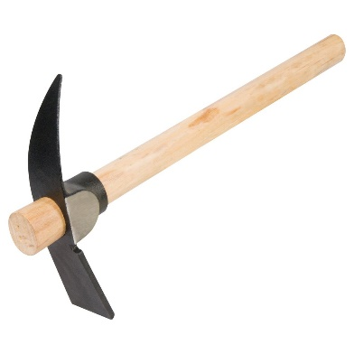
Rail Steel 65mm agriculture farm garden hardware hand tools pick head mattock pickaxe.
Comb مشط, قاشوش
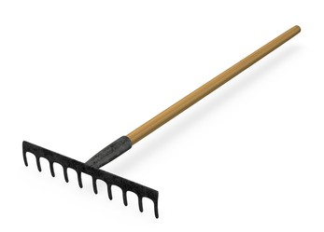
Garden Tools Steel agriculture farming rake 14 teeth garden tools steel agriculture farming rake
Grub Hoe (Shovel M) مجرفة زراعية
Heavy Root Hoe 3.3lbs -7.5” x 5” with 53” Ash Handle
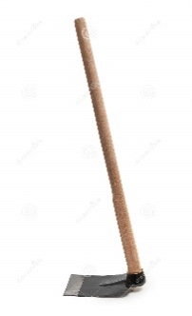
Shovel R
Wood handle – heavy duty
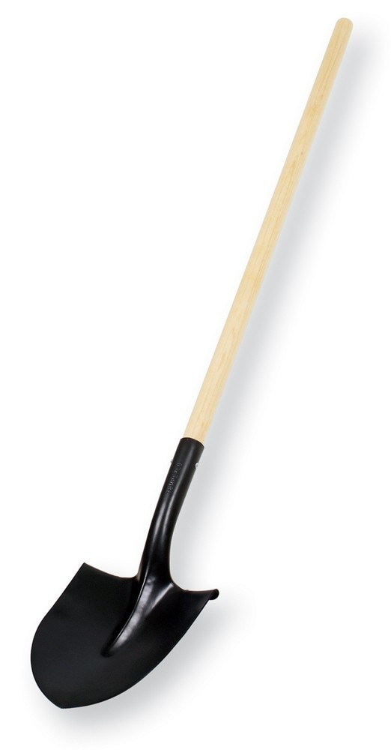

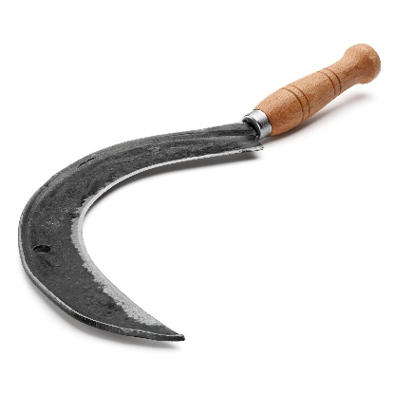
Sickle
Large Broom (heavy duty)

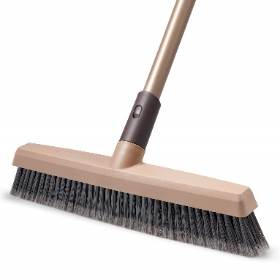
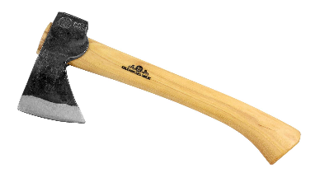
Axe ساطور/فأس
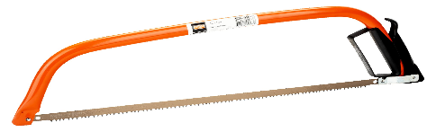
Large hand saw منشار يدوي كبير
Large scissors for firewood مقص كبير للحطب لتشحيل الأشجار
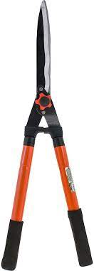

Small scissors مقص صغير

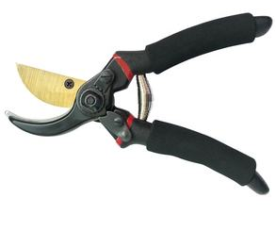
Trash tongs ملقط للنفايات
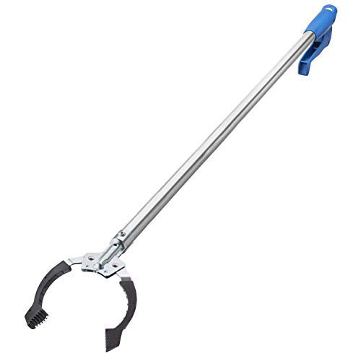
Cut resistant hand gloves
Standard Size
Water 1.5L bottle of water (box of 12)

Plastic trash bags (pack)
XLarge with ties
Cut resistant hand gloves Size: XL

_______________________________________

Supplier’s authorized signature over printed name

