TECHNICAL SPECIFICATIONS
IOM’S SPECIFICATIONS | BIDDER'S SPECIFICATIONS | Indicate  COMPLY or NOT Comply
Folding Ladders Wooden ladder / Swedish Wooden raw material, quality raw material with coating, loading capacity 150Kg.
Size: 6 feet
سلم خشب سويدي
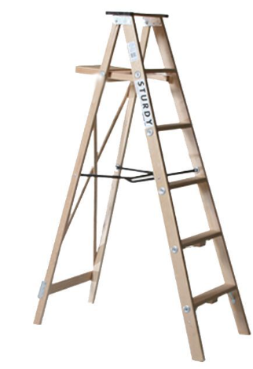
Long scissors for trees / مقص ليمون يد طويلة
Durable Tree Cutting Scissors Long Handle Pruning Garden Shear With High Quality.
Anti-Slip Grip, Folding.
Cutting Capacity: 1 inch
Blade Length: 3 inches
Cutting diameter: 0-40mm
Material: SK5 (Carbon Steel)
Handle: PVC
Size: 680-1005mm
Application: Trees
Finishing: chrome plated
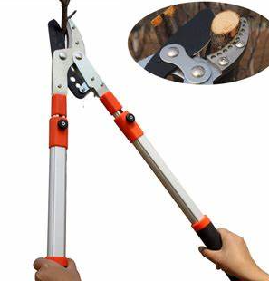
Electric Hedge trimmer / موتير قص ورق
Electric Hedge Trimmer 20v With High-efficiency DC Motor
Power: 450W
Blade: Punch blade,65Mn double-sided
SPM:3200
Weight: approx. 5kg
Scissor Type: DUAL
Length Of Blade and Cutting length: 510MM
Power Source: Battery
No loading speed: 1400rpm
Max cutting capacity: 16mm
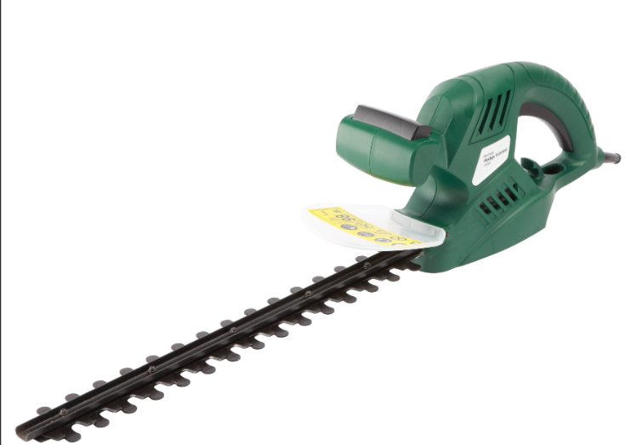
Gasoline lawn mower threads / خيطان مكنة قص
عشب
4-Stroke, Anti-slip, Folding Handle, Grass Box, Height Adjustable Hand
Cutting heights: 1.25in. to 3.75
Cutting Width 20 inches
Power Source: Gas Cutting
Number of cutting heights settings: 6
Drive Type: Self propelled
Oil Volume:0.4L
Catcher Capacity: 65L
Device material: Plastic & Metal
power Source: Petrol/Gasoline
Engine speed: 2800rpm
Gasoline tank volume: 1L
Deck Material: Steel
Height Adjustment: 25-70mm with 8 settings, central
Wheel: Front 178mm & rear 250mm
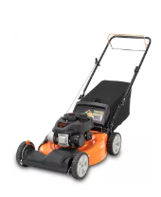
Water hose / نربيش سقاية
Diameter:
1/2",5/8'',3/4"
Hose material: PVC
Color: yellow, red or green
Adavantage: Anti-UV, Anti-Abrasion, Anti-Corrosion, Anti-UV, Flexible, Soft
Working Temperature: -10°C~+40°C
Size/diameter: 4 inches
Length: 30 feet
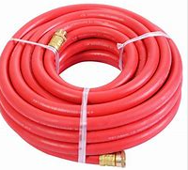
Hand saw / منشار يد
professional level Hand Saw 20inch/500mm High Quality Hand Saw Hand Saws For Cutting Trees
Application: Metal, wood, plastic
Teeth per Inch: 18
Blade Type: FIXED BLADE
Material: Steel and wooden wrist
Blade Length: 20inch
Dimensions: 500mm
Weight: approx. 0.60kg
Color: any
Length of saw blade: 300
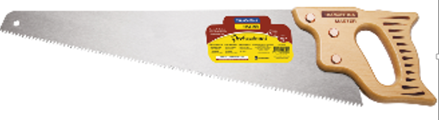
Saw Blades / نسلات منشار
Blade Width: 1.8mm
Teeths: 30
Blade Length: 6 1/2in
Blade Diameter: 4in
Edge Height: 0.315in(8mm)
Size: 110x1.8x20mm
Application: Wood
Material: Diamond Powder+Alloy Steel
Teeth type: BC Teeth
Color: Silver
Thickness: +/-.001”
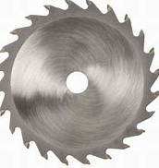
Engine Chain For Cutting Woods / جنزير موتير قص الحطب
Engine Displacement: 25.4cc
Power: 1.0kw
2-Stroke, Forced Air Cooling, Single Cylinder
Power Source: Petrol/Gasoline
Engine type: Air Cooled, 2 Stroke Single Cylinder Gasoline
Rated Output Power&Relevant Speed: 1. 0kw
Fuel Mixture Ratio: 25/1(Gasoline 25: Two-cycle Oil 1)
Fuel Tank Capacity: 230ml
Engine Oil Tank Capacity: 160ml
Guide Bar: 10''
Net Weight: approx. 3.2kg
Type: Handheld
Power: gasoline?
Blade type: Dual
Brake: mechanic
Operation Mode: Double Action
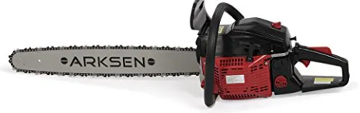
Paper Clips / ملقط اوراق
Small around 22mm
Material: Metal
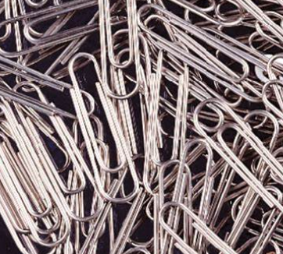
rough comb / مشط خشن
Size: 203mm
Handle Material: 66 nylon, carbon 30%
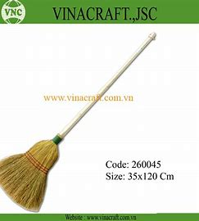
Soft Comb / مشط ناعم
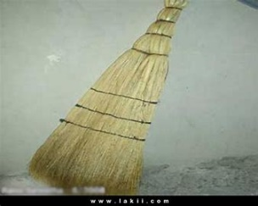
Large lawn mower head / رأس ماكينة الخيط لقص العشب الكبيرة

Volt Brushless Self-Propelled Mower. It holds its own against gas-powered models, has a 20-inch deck that mulches and bags, and an optional side-discharge chute (sold separately). It can run for up to 40 minutes per charge.
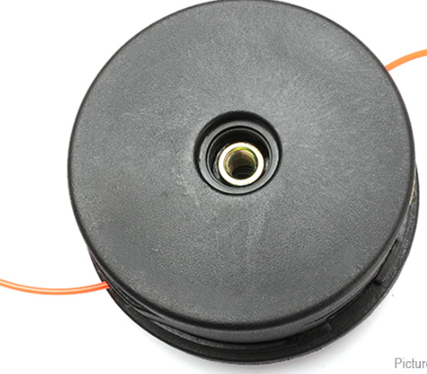
Small Rake / منكوش صغير
Handle length: 150cm
Working width: 36cm
Wooden handle
Head Material: Steel
Handle Material: Wood
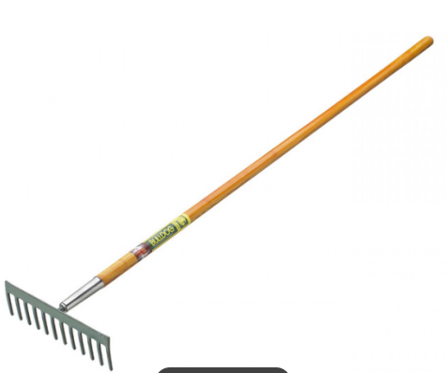
Plastic roller Bin / عرباية نفايات بلاستيك
Corrosion resistant, No absorption, Stackable.
Material: Plastic
Size: 360L
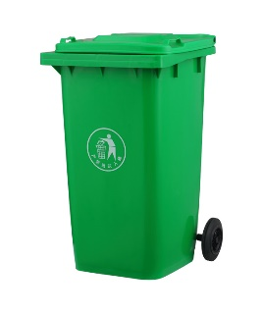
Large scissors / مقص كبير

Material: stainless steel
Blade Length: 4 inch
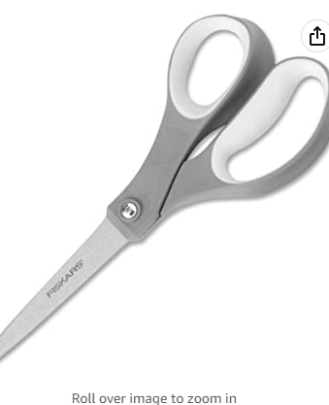
Felco or equivalent
small scissors blade / شفرة مقص صغير

Size: 215mm
Material: steel
Finishing: Not Coated
Max Cutting Capacity: 22mm
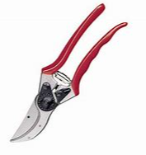
Backpack sprayer for pesticides / مرشه ظهر للمبيدات

Capacity: 16L
Gross weight: 5.5KG
Nozzle: flat
Type: electric
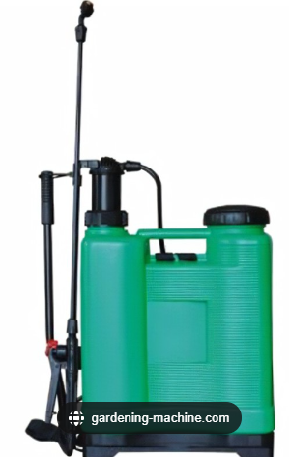
Shovel / مجرفه

Blade Length:
8in
Blade material: Drop forged Carbon Steel
Total length: 39"/1m
Handle Type: D-Grip
Style: Round shovel
Handle material: 1st grade wood handle
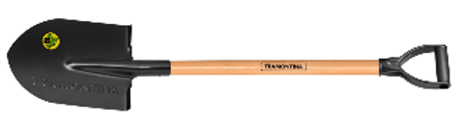
Paint / Black (tinol or similar) for sidewalks (4 KG)
Paint / Phosphore (tenol or similar) for sidewalks (4 KG)
Paint / white(tenol or similar) for sidewalks (4 KG)
turpentine (bottle)
volume: 1L
Paint Roller /Large
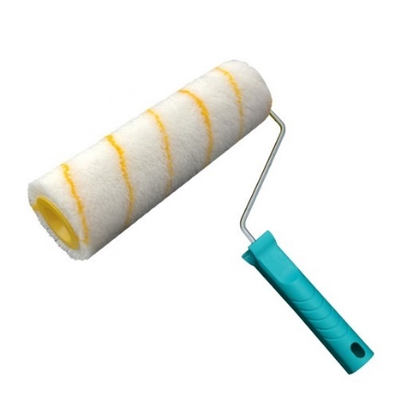
Paint Roller/Small
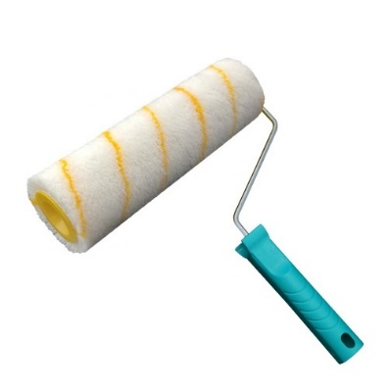
Paint brush, Size 4
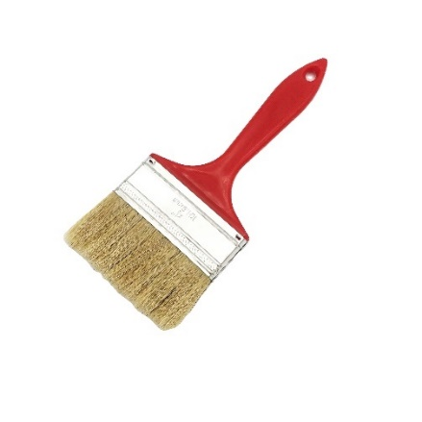
Broom /Large for road sides (Heavy Duty)

Handle: wooden
Brush handle 120*2cm, brus 40*6*2cm, 7.5cm bristle
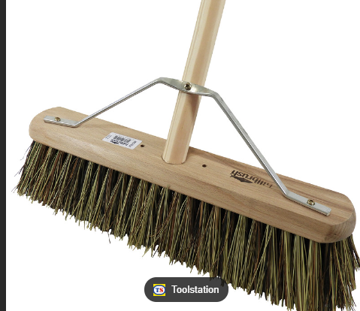
Broom / thin (Heavy duty)

Handle: cabon
Single package size:
150X6X7.5 cm
Single gross weight:
3.000 kg
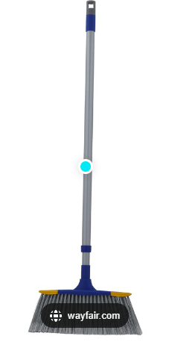
Paint Paste (Galons)
Wall Scraper, Size 4
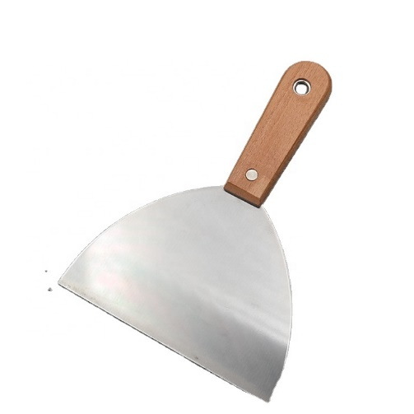
Water tap (neck type)
Turkish brand or similar/equivalent
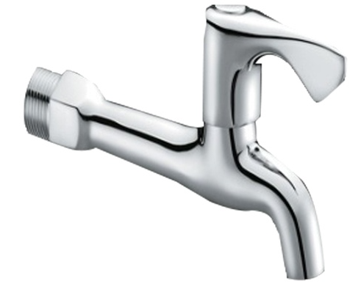
Water mixer
Turkish brand or similar/equivalent
Function: Hot Cold Water
Surface Treatment: Polished
Cartridge: 35mm Ceramic Cartridge
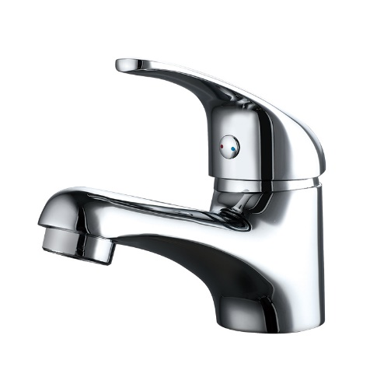

Water riser for toilet
Turkish brand or similar /equivalent
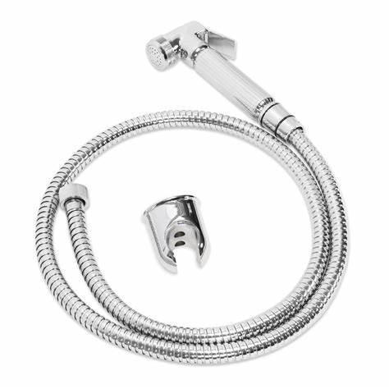

_______________________________________

Supplier’s authorized signature over printed name

